**Crossbar on the C8051F120**

20

18

21

19

16

17

14

15

10

13

12

6

9

4

5

11

30

29

27

28

24

25

22

23

EVB Pin:

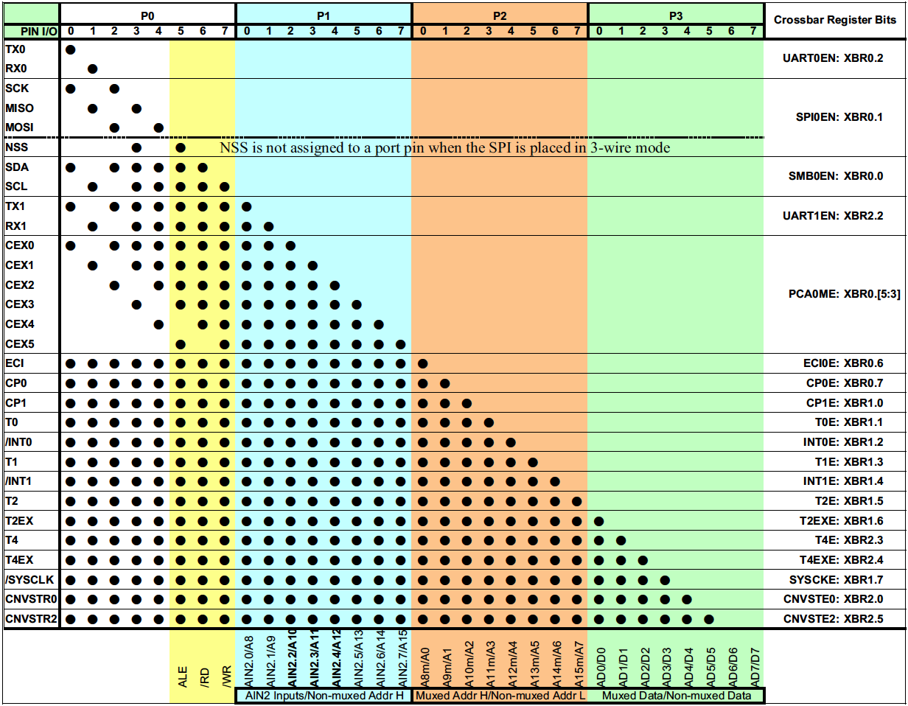

**Priority Crossbar Decode Table**

**7 6 5 4 3 2 1 0**

5 4 3

0 0 0 No CEXn

0 0 1 CEX0

0 1 0 CEX0, CEX1

0 1 1 CEX0, CEX1, CEX2

1 0 0 CEX0, CEX1, CEX2, CEX3

1 0 1 CEX0, CEX1, CEX2, CEX3, CEX4

**XBR0: Port I/O Crossbar Register 0 and Priority Order**

|  |  |  |  |  |  |  |
| --- | --- | --- | --- | --- | --- | --- |
| **XBR0**  **Register** | **CP0E**  Comparator 0  Output  Enable | **ECI0E**  PCA0 Exter-  nal Counter  Input Enable | **PCA0ME**  PCA0 Module I/O Enable | **UART0EN**  UART0 I/O  Enable | **SPI0EN**  SPIO Bus  I/O Enable | **SMB0EN**  SMBus  I/O Enable |
| Priority  Order | 7 | 6 | 5 | 1 | 2 | 3 |

**C8051 EVB Port Connector 1**



*AIN0.1*

*AIN0.3*

*AIN0.5*

*AIN0.7*

AIN0.0

AIN0.2

AIN0.4

AIN0.6

**C8051 EVB Port Connector 2**

