**MPS CAN Lab Exercise**

**Controller Area Network**

Student's name & ID (1): ___________________________________________________

Partner's name & ID (2): ___________________________________________________

Your Section number & TA's name __________________________________________

**Notes:**

You must work on this assignment with your partner.

Hand in a printed copy of your software listings and a neat copy of your schematics for the team.

These will be returned to you so that they may be used for reference.

------------------------------- do not write below this line -----------------------------

|  |  |  |  |
| --- | --- | --- | --- |
|  | POINTS (1) (2) | | TA init. |
| Grade for Part 1 performance verification (10%) |  | |  | |
| Grade for Part 2 performance verification (10%) |  | |  | |
| Grade for part 3 performance verification (20%) |  | |  | |
| Grade for answers to TA's questions (20% max.) |  |  |  | |
| Grade for documentation and appearance (40% max.) |  | |  |
|  |  |  | TOTAL |

Grader's signature: ___________________________________________

Date: ______________________________________________________

**Controller Area Network**

### This lab manual will detail the initial hardware setup for Lab 7. The following is a step by step processes needed to successfully set up the CAN related Hardware as well as discuss Safety related Issues that should be addressed before the use of the device.

# SAFETY

1. Before Use of this device, please review and become familiar with CAN related topics, as this will speed up the process of setup and troubleshooting that may result from use of the CAN system.
2. Voltage levels in this lab are not excessive, but caution must be exercised due to the high amount of current flow through the system. The device *must* be connected to a power supply that can safely limit current to a safe level before use by students. Unacceptable sources of power such as a car battery should not be used with this device.
3. Ensure that the blocks holding the car up are secure and car wheels have at least a 1 inch clearance from the device platform.
4. Do not short any connections on the device. This may result in a fire hazard.
5. Check all connections before the device is turned out.
6. Students should not have access to inner workings of car, unless specified by the instructor.

## GOAL

By doing this lab assignment, you will:

1. Learn about the Controller Area Network Interface on the C8051F040 development board
2. Develop the CAN Transmit and Receive Protocol to communicate with the PIC microcontroller in the R/C car
3. Understand specific applications of CAN in different industries
4. Comprehend CAN Protocols & Hardware
5. Employ NI hardware and LabVIEW software to develop a Graphical User Interface for Data Acquisition

## PREPARATION

References: C8051F04x.pdf 8051 *C8051F04X Reference Manual, Ch. 5, 8, 18*, CAN library documentation

Write a C program that is free from syntax errors (i.e., it should assemble without error messages)

## REQUIRED MATERIAL

### Hardware Requirements

* Two 8051F040 Development Boards with USB SiLabs MCU Programming Adapters
* CAN-Controlled R/C Car (with lights, horn, drive motor, steering servomotor, etc.)
* Meter Box with 3 meters and Control Box with switches and potentiometers.
* 5 Volt DC power supply

### LabVIEW Requirements

* CAN-viewer-MPS.vi
* CAN-sender-MPS.vi
* NI-Tutorial-9759-en.pdf, NI-Tutorial-2862-en.pdf, NI-CAN Channel and Frame API - National Instruments.pdf, Which NI-CAN Frame API Functions does the NI USB-847x Device Support.pdf
* NI CAN Demo Box and USB-8473s or USB-8473 connector(s)
* Two computers (laptops) running LabVIEW 2010 or 2011
* Two Female to Female DB-9 CAN Serial Cables (with terminating resistors - on labeled end)
* Two Female to Female DB-9 CAN Serial Cables (without terminating resistors)
* CAN bus Cable with multiple DB-9 Connectors (Male and Female)

## Controller Area Network Interfaces

### Overview

The Controller Area Network (CAN) is a serial bus communications protocol developed by Bosch in the early 1980's and is used as a standard for efficient and reliable communication between different nodes in industrial applications. One prime application upon which this lab is based is the automotive industry where CAN is used to send data among different nodes in a car.

Each subsystem, such as the engine controller and the instrument panel, shares a common bus for sending and receiving messages. To make sure that higher priority messages that would directly affect car performance are given precedence, a CAN data frame contains a message ID, which doubles as a priority code. Frames with a higher priority (lower ID) win the message arbitration and continue to send the frame whereas those with lower priority (higher ID) back off and wait to retry until the channel is clear again.

By sending frames with the appropriate ID within the CAN network one can either send a command or send a request for data. This lab will require setting up two 8051 development boards on a CAN bus. One board will be a control module that will transmit data only and the other will be a display module that will receive data from the car. The IDs of different messages are listed in Appendix A.

This lab uses a model car that has been set up internally with a CAN controller which receives commands sent to it over the CAN bus and activates the various devices in the car, such as the horn, headlights, drive motor, etc. Below is the block diagram of the internal CAN device. For size, cost, and other factors, it uses a PIC18F2680 microcontroller rather than a C8051F040 microcontroller. None of this makes any difference to the user since the tasks for the students only involve sending commands over the CAN bus and the details of the controller receiving the commands are transparent to the user.

Figure 1: Controller Block Diagram for the Car Chassis Module.

Motor Speed Control

Servo Output

LED Output

Speed Input

Temperature Input

Current Sensor Input

PIC18F25K80

System Controller

CAN Transceiver and Interface

(Airbag Control Output)

The final system configuration for this exercise will have two C8051F040 processor cards connected to the common CAN bus of the Car Module as well as several wires and cables connected to the Control Module, and Meter Module. The block diagram below shows the required electrical connections among the various components of the exercise.



Figure 2: CAN System Layout Diagram.

In the steps leading up to this final configuration, two intermediate configurations will be used. In PART I, the Car Chassis will be replaced with a NI CAN Demo Box, the Control Module will be replaced with a LabVIEW VI for sending commands, and the Meter Module will be replaced with another LabVIEW VI, running on a separate PC, that will be listing the CAN messages and displaying status using various control panel indicators. PART II will keep the two LabVIEW VIs for the modules while switching the NI CAN Demo Box back to the Car Chassis.

### PROGRAMMING TASKS

The first programming task will be a visual programming assignment to develop a more advanced version of the LabVIEW CAN bus monitoring VI that displays all the status information available from the car. The second, C programming, task will require the use of the CAN library that has been provided. Documentation for this library has been provided in HTML format on the course web pages. To interface the 8051 development boards to the car, plug into the male DB-9 connectors on the cables going to the car base station. The female DB-9 connector is for use with a debugging device and will not work with the 8051 development boards. For the CAN baud rate to work correctly, it will be necessary to configure the C8051F040 to use the external crystal oscillator. See can.c where the CAN rate is specified as 500kbps using the 22.1184MHz crystal oscillator.

### PART I - CAN Basics with LabVIEW & CAN Demo Box

To become familiar with the CAN bus hardware and messages, the first task involves using LabVIEW visual programs and a National Instruments CAN Demo Box. The programs allow the user to send commands on the CAN bus and observe them simultaneously using 2 VIs set up on 2 different computers running LabVIEW. Read the NI_User_Manual file on the MPS web page for details on the procedure to install LabVIEW on your laptop. The studio desktops have the software installed but it will be extremely helpful and instructive for students to have their own copies for this exercise.

### LabVIEW Interface for Program Development

The LabVIEW VIs for the Microprocessor Systems course are designed to send and receive CAN messages to and from the CAN Demo Box and RC car in the lab. The front panel features a table that displays all of the CAN data including timestamp, ID, frame type, bytes, and data. There is also the option to filter messages by ID, which is useful when focusing on one specific function or part of the car. The sending VI allows the user to transmit data on a specific ID to the car. This is done manually (no control interfaces such as knobs, etc.) and students who are interested in expanding their LabVIEW skills will be able to expand on this. Start with LabVIEW VIs  
**CAN Receive.vi** and **CAN Transmit – event based.vi** and then move to the similar versions, but customized, **CAN-viewer-MPS.vi** and **CAN-sender-MPS.vi**. NOTE: the default version of LabVIEW is 11, but 2 older versions of these VIs are available, with (10) and (8.6) in their file names.

Some numerical conversions may be required for meaningful data in receiving mode. Sending mode does not require any conversion since the data value is user-defined. This aims to help in the education and understanding of the entire system since the data range must be understood. All pertinent information can be found in the data dictionary.

### PART II - LabVIEW VI Development and RC Car

This portion of the lab will add the RC car to the CAN bus and control its functions with the LabVIEW VIs **CAN-viewer-MPS.vi** and **CAN-sender-MPS.vi**. All the assigned Arbitration IDs from 1 to 11 can be used to activate their respective functions or receive respective status information. The exercise in VI development will have students copy **CAN-viewer-MPS.vi** to a new file and add new control panel indicators to the new file. The goal is to create a VI that is able to display all the functions and status available on the RC car.

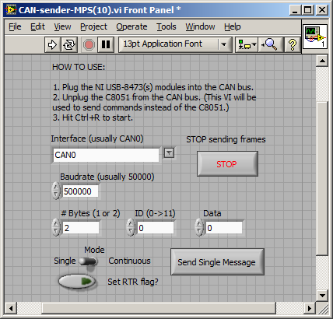

**Figure 3: The CAN-sender-MPS.vi front panel for sending CAN commands on the bus.**

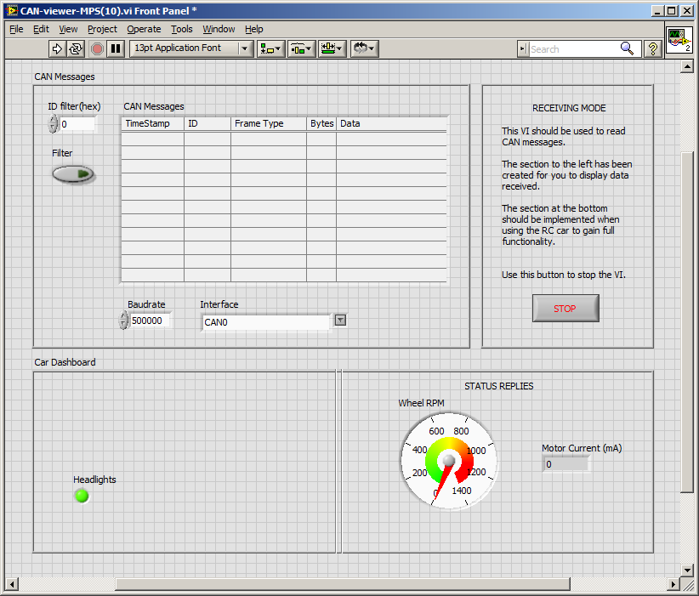

**Figure 4: The CAN-viewer-MPS.vi front panel for monitoring and displaying CAN bus information.**

After becoming familiar with both of these VIs and their block diagrams, one of the objectives of PART II is the development of an enhanced monitoring program that displays the rest of the car data. On possible example is shown below. In addition to the list of CAN commands passed on the bus and the three indicators (Headlight, Wheel RPM, and Motor Current), students are asked to add indicators for:

Left & Right Turn Signals (may be activated together as a warning light)

Horn

Wheel Steering Position (from -20° to +20°)

Drive Motor Input Voltage

Motor Temperature in °C (from a Status Reply message)

Left & Right Turn Signal Status (from a Status Reply message)

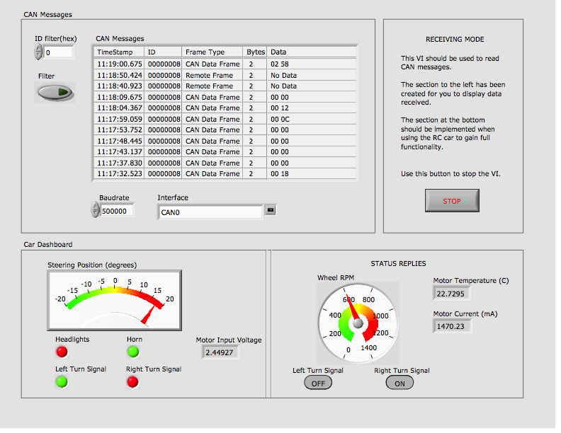

**Figure 5: A typical student-developed front panel for monitoring and displaying all CAN bus information from the RC car.**

### Important Notes on the RC Car

All the functions on the car work, however the drive motor may cause some problems. The input voltage must be above a threshold of ~1.3V before the wheels will turn, and even at that the wheels will need a kick-start turn. A high enough starting voltage will start the wheels without a kick-start. The drive motor is extremely noisy, electrically, and attempts to reduce the EMI have not been successful. If the motor is left running for more than a few seconds the EMI can almost be guaranteed to crash the PIC microcontroller. If that happens, the car stops responding to all CAN commands and must be reset by cycling the 5V power supply. This is inconvenient, but not insurmountable as to prevent the lab exercise from being completed.

The RC car will automatically send a message with ID 8 every few seconds giving the wheel RPM value. This is the only data sent without a request command. To get the status of the temperature, motor current, and turn signals a CAN command must be send with the desired ID and the RTR flag set (in the sender VI panel or in CAN command function call).

**PART III - C Programming: Separate Control Module and Meter Module**

In this portion of the lab, write a simple program which will turn on the car’s headlights by sending a CAN message containing the bytes 0x0001 with ID 0x01. This will require use of the can_init( ), can_get_tx_buf( ), can_set_address_std( ), can_set_buffer_data( ), can_send_tx_buf( ), and can_send_rtr( ) functions. You may also wish to test CAN message reception using the can_get_rx_msg( ), can_get_address( ), can_get_data_byte( ), and can_free_rx_msg( ) functions.

Expand upon the code to read values from the two potentiometers (steering and acceleration) and the switches (lights, left & right turn signals, and horn) on the car Control Module. The Control Module is the black box with two toggle switches, a push-button switch, and two potentiometers, shown in the lower left part of the figure below. Your code should control the headlights, turn signals, steering, drive motor, and horn on the car. Transmit these values to the car’s CAN bus using the same functions used in Part I. Please see Appendix A for the CAN IDs to be used for each controlled item, and appendix B for the pin-out of the control’s connectors.

Using the functions can_init( ), can_get_rx_msg( ), can_get_address( ), and can_get_data_byte( ), develop code for the 8051 to drive the analog meters and turn signal LEDs. Your code should display the readings from the temperature, speed, and current sensors as well as the turn signal status. Since the C8051F040 only has 2 D/A converters, it will be necessary to enable Pulse Width Modulation (PWM) using the 8051’s PCA to drive the temperature meter. Please see the 8051 reference manual, chapter 24 on the programmable counter array (PCA) for further information. You may also want to refer to your Embedded Control notes to refresh your memory for PWM implementation on the 8051. See Appendix A for information on CAN IDs, Appendix B for information on the pin-out for the meters and more details on all signal wiring and Appendix C for sample program code.

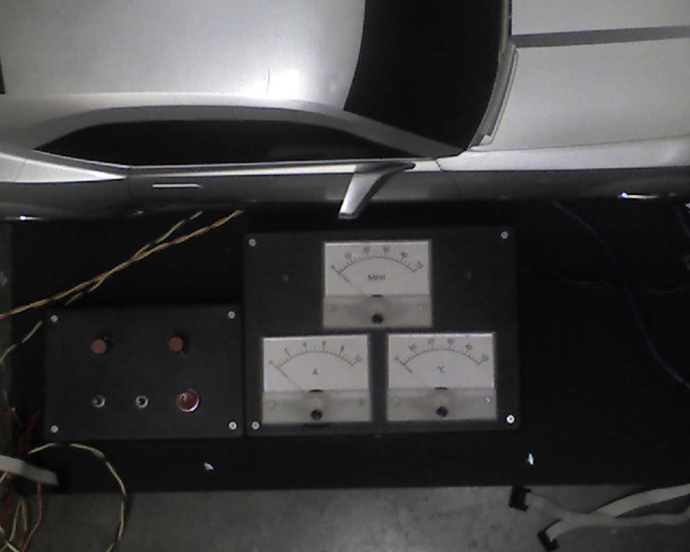

Figure 6: Car Control Module Box (lower left) and Analog Meter Module Box (lower right).

**USAGE GUIDELINES AND INSTRUCTIONS**

1. 1. Safety
   1. a. While the voltages used in this project are not dangerous, there may be a danger of damage to the hardware due to excessive current flow. It is necessary to always connect this device to a power supply that limits current to a safe level. Unsafe power supplies include devices such as car batteries.
   2. b. Do not short any connectors as damage or fire may result.
   3. c. Always verify that the drive wheels are off the ground before attempting to start the car’s motor. Also ensure that the front wheels are free to turn.
2. 2. Initial Setup / Components Identification.
   1. a. It is necessary to supply +12V, +5V, and -5V power to the unit. Identify the 2 twisted-pair power cables from the car. Each has a red and a black plug, and the red plug is labeled with a voltage. The black plug corresponding to the +12V red plug is ground. The black plug corresponding to the +5V red plug is -5V.
   2. b. There are 3 DB-9 connectors on the CAN bus cable. The two male connectors have the correct pin-out to interface to the C8051F040 development boards in the lab. The female connector follows OBD-II standard pin-outs and is suitable for connection to certain other commercially available CAN devices.
   3. c. The order of power supply power-up sequencing is unimportant, but it is important to check all power connections for correct voltage and polarity before turning on power.
3. 3. Use of CAN Interface
4. 11-bit CAN message IDs are used for all communication.
5. The CAN interface on the car will receive messages with several message IDs. (See Appendix A.)
6. The CAN interface on the car transmits several messages with real-time data from sensors. (See Appendix A.)
7. The C8051F040 development boards need to be plugged into the Control and Meter Modules to correctly send and receive CAN information. Each 10-pin connector should be placed on the pins such that pin 1 of the connector aligns with pin 1 of the port (except for the DAC - see 2b in Appendix B). This corresponds to having the end of the connector with the ribbon on it facing the side that the power to the board comes in on.

## Using LabVIEW 2011

### Overview

LabVIEW has two main views, the block diagram and the front panel. The front panel can be thought of as the graphical display where the user interacts directly with the system, and the block diagram as the “code” itself. Pressing **CTRL+E** will switch between these two views and **CTRL+T** will tile them side-by-side. Right-clicking on the front panel will bring up the menu where controls and indicators can be added. This is shown in 7 below. Also shown are the “Run” and “Abort” buttons in the red highlighted area. Never use the abort button to stop a running VI. Always use the “Stop” button which is included on the front panel (added by the user).

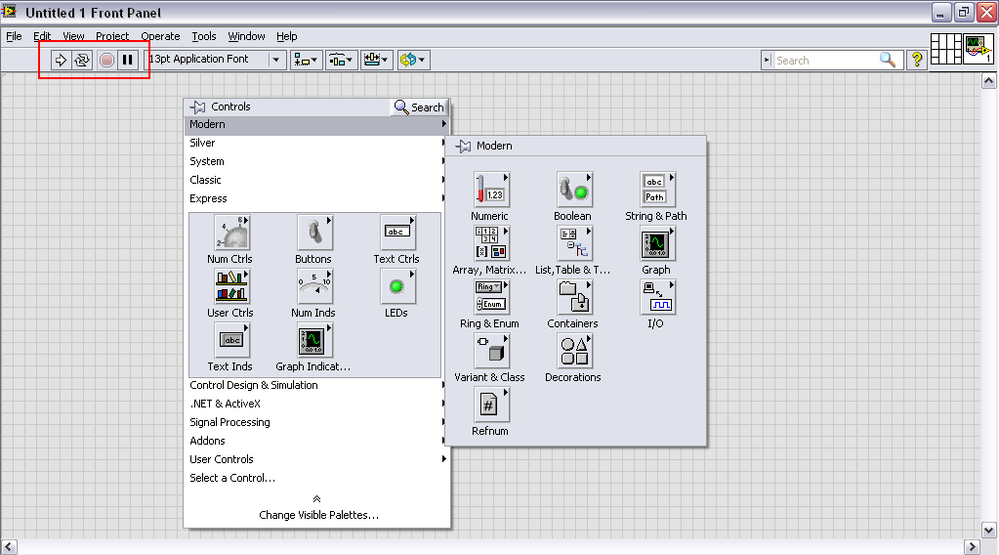

Figure 7: A Blank LabVIEW Panel Showing the Open Control Menu.

### Instructions

1. Configure the NI hardware and software tools to send and receive CAN messages. This includes using the Demo Box and USB connectors to create a bus connecting two computers both running LabVIEW, the RC car, and the Demo Box. Study the message format and protocol.
2. Now, connect to the RC car. Using the same LabVIEW VIs, edit the block diagrams and/or front panels to properly display data received from the car. You should also be able to send data to the car and have it respond appropriately.
3. Finally, implement this LabVIEW functionality in C for the C8051F040 microcontroller.

### Adding Sensors

An essential part of the LabVIEW block diagram is the case structure which allows for multiple indicators on the display to be updated based on the arbitration ID. One of the learning objectives in this lab is to add cases for the other parts of the car (some are given to start). This means that the ID must be known and the type of indicators which makes the most sense to display the given data must be chosen. Again, choices can be made based on the data dictionary. e 8 shows the block diagram with the highlighted option to add a new blank case.

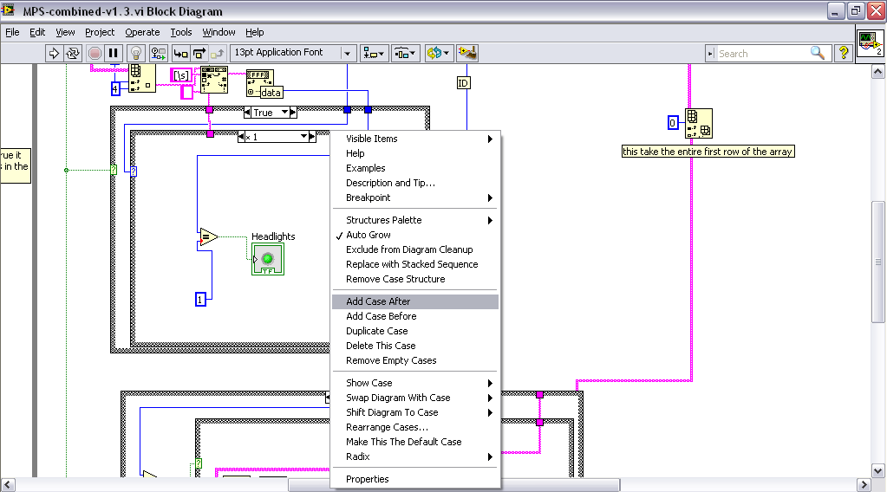

Figure 8: Adding A New Sensor in the Case Structure.

# Hardware Setup (PARTS II & III)

### The following is a detailed description of device hardware setup. Please follow steps in order to ensure proper device function.

1. Identify the 2 twisted-pair power cables from the car. Each pair has a red and black pair, with the red being labeled with the proper voltage that it needs to be plugged into. The black plug corresponding to the red plug is ground. Similarly the black plug accompanying the +5V red plug is also ground. Secure these to the proper power supplies as seen in the following figure, before powering on the device.

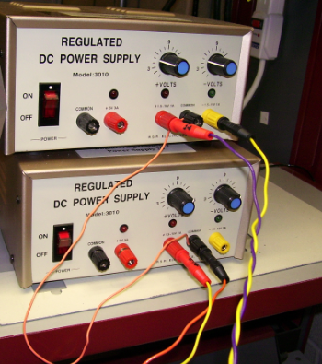

Figure 9: Power Supplies.

1. There are 3 DB-9 connectors on the CAN bus cable. In order to interface with the NI MCU Adapter, the **male** DB-9 Connector must be connected to the **Female to Female Adapter** before being plugged into the corresponding blue NI Female DB-9 connection. This is shown in the following Figure 10 below.

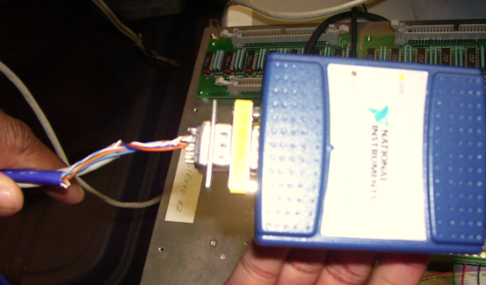Figure ‑: NI USB Connection



Figure 10: NI USB Connection.

1. The NI USB 8473 Device must be connected to CAN controller mounted inside the car frame. Take the **blue** wire connected to the male DB-9 head from Step 2, and connect its end to the CAN controller on the inside of the car. This connection is shown in the following Figure 11.

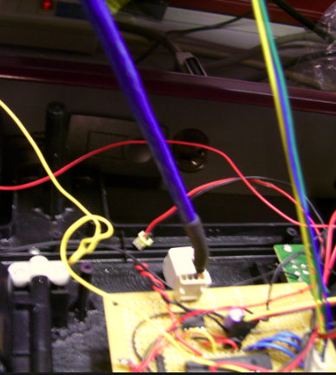

Figure 11: NI USB Connection with CAN MCU

1. The 8051 development boards need to be plugged into the control and meter box modules to ensure the proper delivery and receiving of CAN information. Each 10-pin connector from the modules should be plugged in such that Pin #1 aligns with the corresponding Pin #1 on the port of the MCU. If this has been plugged in correctly, the ribbon should be facing **towards** the power connection of the board. This correct configuration is shown in the following Figure 12.

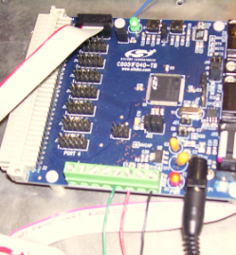

Figure 12: 8051 Power Connection and Module Plug In

1. The ***Control module*** has 3 wires and one 10-pin connector. The black wire should be attached to analog ground and the red and green wires are to be attached to the ADC outputs. These values read in from the two potentiometers are specifically used for speed and steering. The 10 pin connector reads in values as follows:
2. *Not Used*
3. *Not Used*
4. *Temperature (PWM signal)*
5. *Not Used*
6. *Turn left signal*
7. *Turn right signal*
8. *Not Used*
9. *Not Used*
10. *Connected to port power on pin 9*
11. *Not Connected*

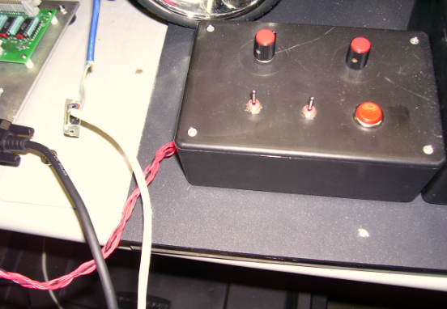

Figure 13: Control Module

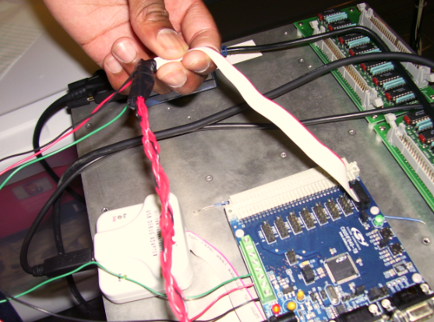

Figure 14: Control Module Connection with C8051 Development Board

1. The **Meter module** has 1 output wire and 2 10-pin connectors. The one wire is for ground and should be attached to the analog ground. The two 10-pin connectors differ by how bright the red stripes on them are. The cable with the darker red stripe is for the port pins and has the following pin-out:

All car lights

Right turn signal

Left turn signal

Buzzer

Not Used

Not Used

Not Used

Not Used

Port power (Not Used)

Unconnected

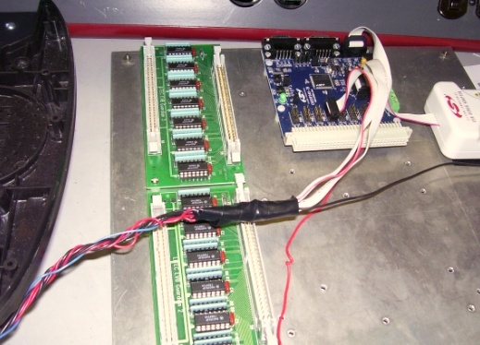

Figure 15: C8051 Connection with R/C Car

1. Check to ensure the 2 - LED lights on the plastic car case are connected and secured to the CAN Network board. These should ideally not be removed. The wires are shown in the following Figure 16.

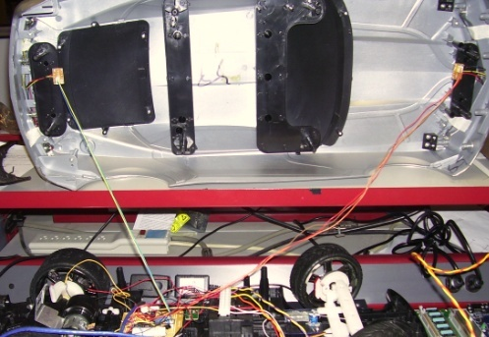

Figure 16: LED Head/Tail Light Connections

1. After All Modules have been connected properly, place the large plastic cover over the inner parts of the car. The plastic cover should ideally be screwed on to discourage the students from tampering with the inner workings.

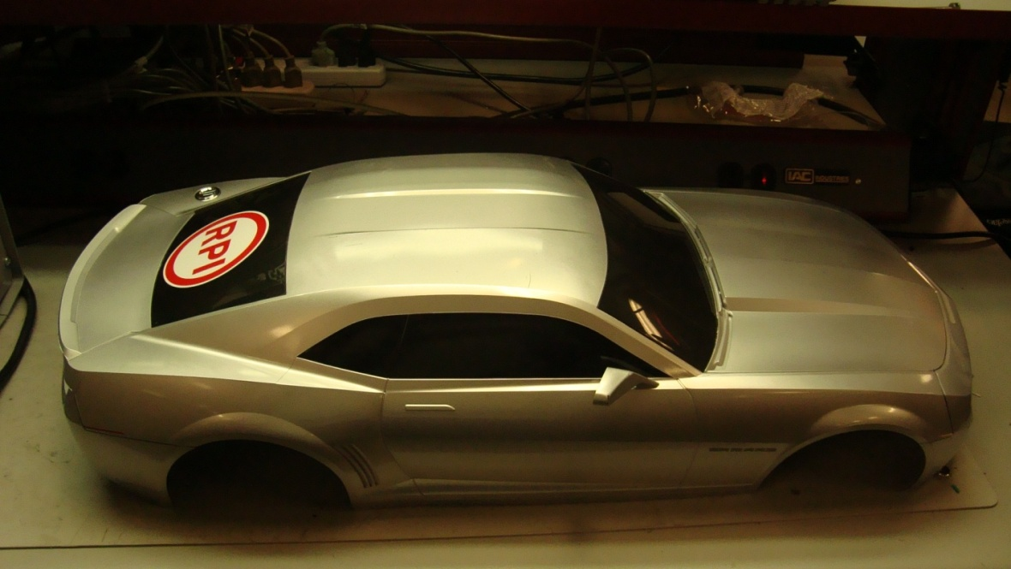

**Figure 17: RC Car Cover**

The following is a complete Wired Block Diagram for the CAN System. It includes the National Instruments USB 8473 Connection Device that is detailed in the NI Hardware Manual.

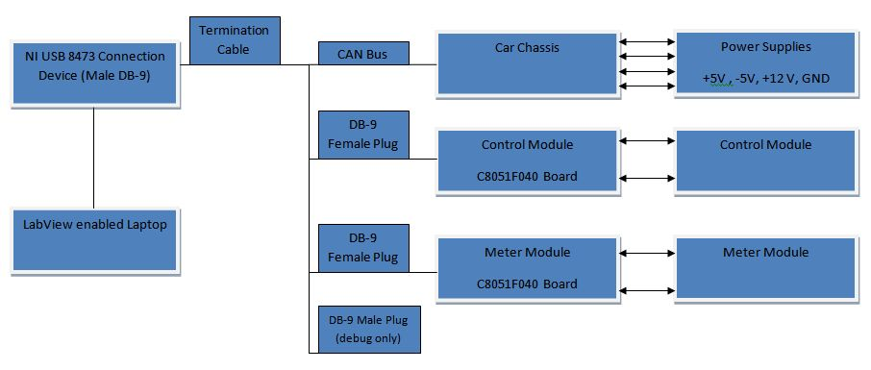

Figure 18: Wiring Block Diagram

## APPENDIX A: CAN Addresses

Full documentation is available on the web at:

<http://www.rpi.edu/dept/ecse/mps/mps_handouts.html>

* 1. The CAN interface on the car will receive messages with several message IDs:
     1. 0x01: Headlights. This message should contain 2 data bytes. These data bytes represents the desired state of the headlights on the car. 0x0000 turns the headlights off, and any non-zero value turns them on.
     2. 0x02: Left Turn Signal. The format of this message is identical to that for 0x01: Headlights. When this feature is activated, the left front and rear signal lights will blink at a frequency of approximately 1 Hz.
     3. 0x03: Right Turn Signal. The format of this message is identical to that for 0x01: Headlights. When this feature is activated, the right front and rear signal lights will blink at a frequency of approximately 1 Hz.
     4. 0x04: Horn. This message should contain 2 data bytes. If these data bytes are non-zero, the horn will begin to sound. If 0x0000 is received, the horn will stop sounding.
     5. 0x05: Motor Speed. This message should contain 2 data bytes with a value between 0 and 4095. [The first data byte represents the motor power as a value from 0x00 (0) to 0xff (maximum power.) The second data byte represents the motor direction. 0x00 represents forward and 0x01 represents reverse.] In the current hardware, reverse is not implemented and can’t be used.
     6. 0x06: Steering Position. This message should contain 2 data bytes. These bytes represent the pulse width (in 10-us units) that will be sent to the steering servo. This value should vary between 0x352 (850) and 0x866 (2150), with the servo center position being at 0x5DC (1500). Inputting values outside the valid range will result in undefined behavior.
  2. The CAN interface on the car transmits several messages with real-time data from sensors (RTR set high):
     1. 0x07: Motor Temperature. This transmits the temperature sensor output voltage as a value on a linear scale from 0 (-50 °C) to 1758 (150 °C); 50 °C => 910.
     2. 0x08: Speed. This transmits the rotational speed of the wheel in counts/second. The sensor counts twice per wheel rotation so actual rotations per second is this value divided by 2.
     3. 0x09: Motor Current. This transmits the current flow measured through the motor, as a value on a linear scale from 0 (0 milliAmps) to 4095 (2174 milliAmps).
     4. 0x0A: Left Turn Signal. This outputs the state of the left turn signal (0x00 for off and 0xFF for on.)
     5. 0x0B: Right Turn Signal. This outputs the state of the right turn signal (0x00 for off and 0xFF for on.)

Table 1: Car Controller Command Functions (& specifications for potentiometers outputs)

|  |  |  |
| --- | --- | --- |
| Function | Message ID | Data |
| Headlights | 0x01 | 2 bytes: 0=Off 1=On |
| Left Turn Signal | 0x02 | 2 bytes: 0=Off 1=On |
| Right Turn Signal | 0x03 | 2 bytes: 0=Off 1=On |
| Horn | 0x04 | 2 bytes: 0=Off 1=On |
| Drive Motor | 0x05 | 2 bytes. 0 - 4095 |
| Steering Servo Motor | 0x06 | 2 bytes: 850 (right) - 2150 (left) |

Table 2: Car Meter Monitor Functions (specifications for analog meters)

|  |  |  |
| --- | --- | --- |
| Function | Message ID | Data Format |
| Temperature | 0x07 | 2 bytes: ADC Reading 0 – 4095  (50 °C => 910) |
| Rotational speed | 0x08 | 2 bytes: 0 - 1400 |
| Current draw | 0x09 | 2 bytes: ADC Reading 0 - 4095 |
| Left Turn Signal | 0x0A | 1 byte: 0=Off 0xFF=On |
| Right Turn Signal | 0x0B | 1 byte: 0=Off 0xFF=On |

**With a 3.0V reference voltage** (the maximum valued allowed with a 3.3V power supply):

The analog meters go from 0 to full scale with an analog input voltage from 0V to 3.0V.

With PWM driving the 3rd meter, 0% - 100% pulse widths will drive the meter from 0 to ~50°C

## APPENDIX B: Module Pin-outs

* 1. The C8051F040 development boards need to be plugged into the Control and Meter Modules to correctly send and receive CAN information. Each 10-pin connector should be placed on the pins such that pin 1 of the connector aligns with pin 1 of the port (except for the DAC, see 2b below. This corresponds to having the end of the connector with the ribbon on it facing the side that the power to the board comes in on.
     + 1. 1. The Control Module has three wires and one 10-pin connector. The black wire should be attached to analog ground (J20-8) and the red and green wires are to be attached to the ADC inputs (J20-5 & 6). These read in values from the two potentiometers for speed and steering. The ribbon connector may be attached to any port 2 – 7. You just must keep track of which port is used when developing the control module software. Pins 1-4 must all be configured as inputs with open-drains and weak pullups. The 10-pin connector reads in values to the C8051F040 as follows:

1. All car lights

2. Right turn signal

3. Left turn signal

4. Buzzer (Horn)

5. Not Used

6. Not Used

7. Not Used

8. Not Used

9. Port Power (Not Used)

10. Ground (Not Used)

* + - 1. 2. The Meter Module has one output wire and two 10-pin connectors. The single wire is for ground and should be attached to the analog ground screw terminal on the development board (J20-8). The two 10-pin connectors differ by the appearance of the red stripes on them.
      2. a. The cable with the solid red stripe is for the port pins and may be attached to any port 2 – 7. You just must keep track of which port is used when developing the meter module software. Pins 3, 5 & 6 must be configured as outputs with Push-Pull. The10-pin ribbon cable’s pin-outs from the C8051F040 are wired as follows:

1. Not Used

2. Not Used

3. Temperature (PWM signal)

4. Not Used

5. Turn left signal

6. Turn right signal

7. Not Used

8. Not Used

9. Port Power

10. Ground (Not Used)

* + - * 1. b. The cable with the dashed red stripe is for the DAC outputs. Only the middle two pins are used (J11-3 & 4). These are for DAC0 and DAC1 respectively. Therefore the 10-pin connector should be placed on the 6 pins of the DAC output (J11, see development board manual) such that the 6 pins are centered in the connector (pins 1 & 2 and 9 & 10 on the cable are unconnected).

## APPENDIX C: Pseudo-Programming Example

/*

* Note that these examples do not include everything necessary for fully

* working CAN. It is necessary to set up the crossbar and system clock

* correctly in order for the CAN module to work properly.

*/

/* Example CAN Transmission Code */

/* This will send a 3-byte message (0x12 0x34 0x56) to 10-bit address 0x123 */

#include "can.h"

/* ... */

unsigned char data[3] = {0x12, 0x34, 0x56};

CAN_BUFFER canbuf;

can_init( );

/* ... */

while (1) {

/* ... */

if (want_to_transmit_something) {

canbuf = can_get_tx_buf( );

can_set_address_std(canbuf, 0x123);

can_set_buffer_data(canbuf, data, sizeof(data));

can_send_tx_buf(canbuf);

}

/* ... */

}

/* Example CAN Reception Code */

/* This will receive a message and print its contents to the terminal */

/* Might also be useful for testing purposes */

#include "can.h"

/* ... */

unsigned char data[8];

CAN_BUFFER canbuf;

can_init( );

/* ... */

while (1) {

/* ... */

canbuf = can_get_rx_msg( );

// check if anything was actually received

if (canbuf) {

printf("Length: %d\n", can_get_dlc(canbuf));

printf("Message ID: %04x\n", can_get_address(canbuf));

printf("Data: ");

for (i = 0; i < can_get_dlc(canbuf); ++i) {

printf("%02x ", can_get_data_byte(canbuf, i));

}

printf("\nEnd of Message\n");

}

}

**APPENDIX D: RC Car CAN Arbitration IDs, Functions, and Value Ranges**

