School of Engineering & School of Architecture
(January 18, 2016 r1)

PRINT NAME_________________________________ DATE _______________________

Please sign this test here _______________________________________________________
In signing this test, I acknowledge that I have carefully read and fully understand the general safety rules and operational policies of the School of Engineering’s fabrication & prototyping areas, and I will comply with them. I also realize that other, undefined hazards will exist in the fabrication & prototyping area and therefore, my safety, and that of others, is ultimately my own responsibility.

CLASS_________ SECTION____________

Directions: You must get 25/25.

1. Working alone in a shop or fabrication area is okay if you are not using powered tools or electronic devices.
2. You are responsible for housekeeping and cleaning up after you are finished working on a project.
3. You can cut any type of plastic on the laser cutter.
4. Unsealed lead-acid batteries, such as maintenance free car and motorcycle batteries, are acceptable.
5. Personal power tools can be used without restriction.
6. Students are allowed to fabricate pressure vessels from plastic pipe and common plumbing fittings.
7. While using a chisel it is safe to do the following:
- Hold work piece in my lap
- Hold work piece with other hand in front of chisel
- Clamp work piece to bench
- All of the above
8. Identify the following managers.

- Manager of Fabrication & Prototyping, School of Engineering
- Manager of Fabrication & Prototyping, School of Architecture

A. John Szczesniak, B. Dean Garde, C. Sam Chiappone, D. Bill Bergman
9. Safety glasses are only required when working with power equipment. You do not need glasses when you are working at an electronics bench in a shop area.
10. In case of a fire or hazardous chemical spill evacuate the area immediately.
11. You can use the shop or fabrication area whenever you find a door open even if your class TA or professor is not present in the lab.
12. You must report all injuries to your instructor, TA, or staff person.
13. Painting can be done at your workbench.
14. Students supervising fabrication areas are allowed to approve the use of line voltage above 24V.
15. You should not drain dispose any chemical without first consulting an instructor or staff person.
16. The best way to learn how to use a power tool is trial and error; no need to ask for instructions.
17. Safety glasses are available for purchase at Pfeil Hardware , Home Depot, and ____________.

1. Price Chopper
2. DCC Food Chart
3. Rensselaer Union Bookstore
4. Core Engineering Office

18. Student lab supervisors do not have the right to ask a student to leave the shop area due to a safety violation.
19. The Emergency phone number for RPI-Public Safety is 276-[ ]. A campus phone uses the last four digits only.
20. Select all acceptable foot gear in the fabrication areas.
- All
- 1 & 2
- 3 & 4
- None
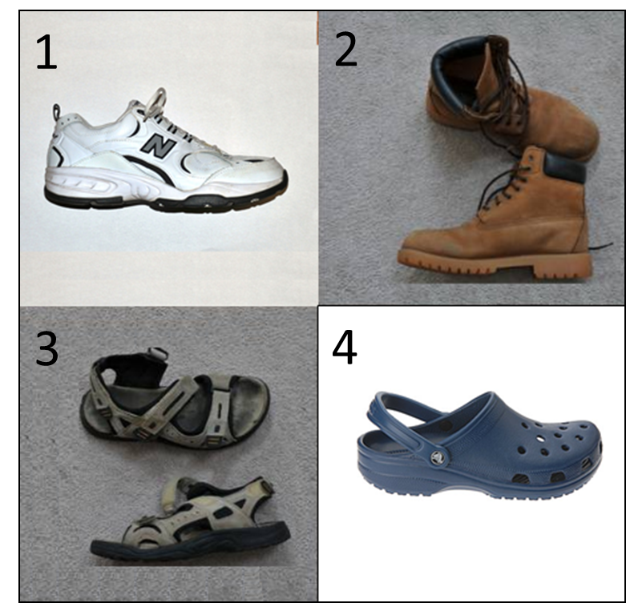
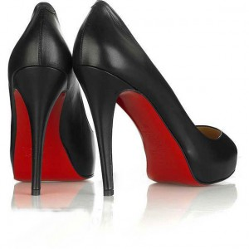
21. All electrical devices using a 3 prong plug AC line must be connected to a 3 conductor extension cord or 3 conductor outlet.
22. Treated lumber can be cut in the Architecture Fabrication shop.
23. MDF (Medium Density Fiber) board can be machined in:
- The Processes lab
- The Design Lab
- Architecture Fabrication Shop
- Advanced Manufacturing Lab
24. Safety is everyone’s responsibility and you should report any unsafe act or situation to your instructor or staff person.
25. I acknowledge that I have carefully read and fully understand the general safety rules and operational policies of the School of Engineering’s and the School of Architecture’s fabrication & prototyping areas, and I will comply with them. I also realize that other, undefined hazards will exist in the fabrication & prototyping area and therefore, my safety, and that of others, is ultimately my own responsibility.
Yes, I agree.
No, I do not agree.

