Project 4

Optical Communications Link

This is a team project, 1 report for the entire team.

In this project you will build a transmitter and a receiver circuit. The transmitter circuit uses pulse frequency modulation to create a series of light pulses that encode an audio signal. The receiver takes in the light pulses, demodulates them, amplifies the signal back to the level the audio amplifier needs to see, and sends it through an audio amplifier to a speaker where it can be heard. Your initial design will reconstruct the input to create an audible signal of poor quality. In the final design, you will modify the circuit to create a much better quality demodulated audio signal.

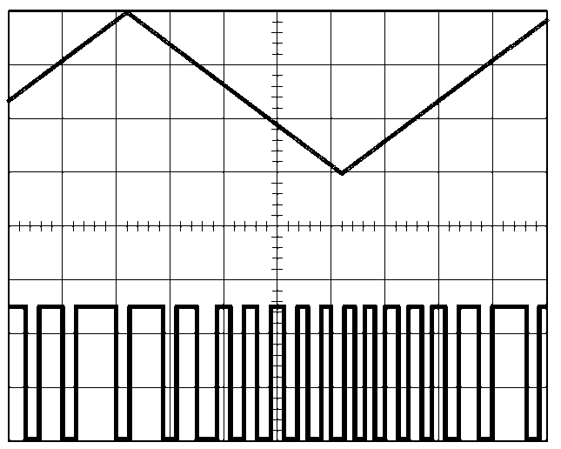

**Figure 1.**

Figure 1 shows an input signal (top) and its pulse frequency modulated equivalent. Simply averaging this signal will demodulate it to some extent. The initial design for the receiver circuit provides this functionality more-or-less by accident. If you enhance the time-averaging ability of the circuit with the addition of an integrator, you will be able to improve the reconstruction of the audio signal. The integration, however, will alter the signal level somewhat. To make up for this, you will have to adjust the gain of the circuit after the integrator is added. You will also be asked to add a smoothing capacitor to the circuit to further improve your output signal. The modified circuit is to be tested to be sure that it is an improvement over the initial design.

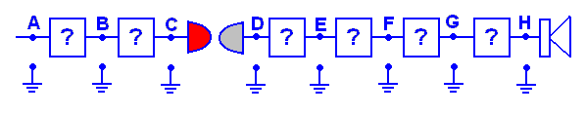

**Figure 2.**

Another part of this project is to determine what each block of the circuit you are building does. Figure 2 shows a block diagram for the circuit. The piece of the circuit between each of the marked points is a sub-circuit that performs some function. You have encountered most of these smaller circuits sometime during the semester. You should be able to identify the function of each block shown in Figure 2 and show that the block is functioning as expected by comparing the signal before the block to the signal after it.

**Part A - Initial Design**

In the initial design of this circuit you will build a transmitter and a receiver. You will also use a *LTspice* model of the circuit and the optical transmission and reception process to better understand how this all works together.

Transmitter Circuit

The initial transmitter circuit is pictured in Figure 3.



**Task #1: Draw this circuit by hand.**

**Figure 3. Use same IR LED as was used in Exp. 8**

The voltage at point A is your input signal. In this project, you will examine the behavior of your circuit for two different types of input waves: a periodic (sine or square) wave from the function generator and an audio source. Note the location of the three points: A, B and C. These points define the input and output to the blocks in the circuit. For example, the block between A and B is a DC blocking capacitor. It keeps the DC offset introduced by the 555 timer from interfering with the input signal (which has no DC offset). Block B-C is the 555 timer circuit that samples the signal. All of the measurements in this project should be taken with two channels of the scope and they should be measured with respect to ground. The 50K pot is marked 503. Use a 100k pot (104) if you don’t have the 50k. This pot can change the sample frequency of the 555 timer block.

Receiver Circuit

The initial receiver circuit is shown in Figure 4. The 100Ω resistor limits the current from the OP27 op amp.



For typical speakers,  
 Ls ≈ 100µH and Rs ≈ 8Ω

**NOTE Resistor**

**Task #2: Draw this circuit by hand.**

**Figure 4. Use the same IR photo transistor as was used in Exp. 8**

In this circuit, the input is the light pulses detected by the phototransistor. The output is a demodulated and amplified signal heard on a speaker. Note the locations of the points D, E, F, and G. You will be measuring the voltage signals at these points and defining the circuit blocks between them.

**Note: only one team member needs to build these circuits. At least that student should look at Experiment 8, Part C – LEDs, Photodiodes and Phototransistors. That part was dropped for the Spring 2021 semester of EI but has the information needed to identify and use the IR LED, D1 of Figure 3, and the IR phototransistor, Q1 of Figure 4.**

The project uses the small speaker that is provided in the ADALP2000 kit of parts. That kit also has a phone jack can allow the use of ear buds instead of the speaker. For checkoff it is best to at that point use the speaker.

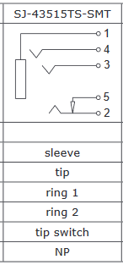

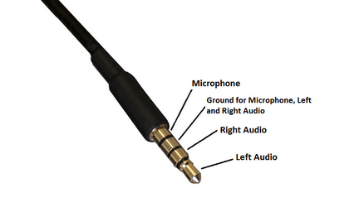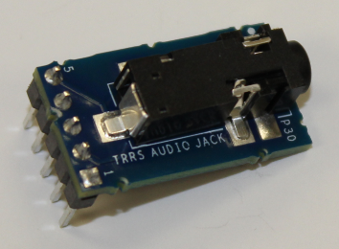

source: <https://www.cuidevices.com/product/resource/sj-4351x-smt.pdf>

Use pins 2 and 3 for sound in both ears.

Source: ADI site: <https://wiki.analog.com/university/tools/adalp2000/parts-index>

Source: <https://www.circuitbasics.com/how-to-hack-a-headphone-jack/>

**The audio amplifier – optional enhancement.**

The OP-27 isn’t designed to drive a speaker as was indicated in Experiment 4 when you connected a small resistor to output of the op amp and the signal was distorted. The LM386 is an audio amplifier that is capable of driving a speaker and is available if your team wishes so use one. Figure 5 shows a typical circuit for the LM386. This circuit would be placed at point F as shown in Figure 4 for the physical circuit, it wouldn’t be included in the LTspice model. Note that this circuit drives the speaker without a current limiting resistor, R23 of Figure 4. It can provide a louder output.

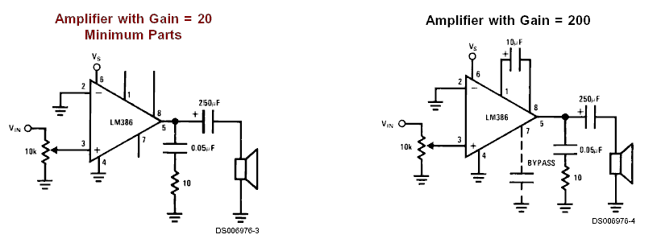

**Figure 5. Audio Amp, not used in present version of Project 4  
The chip is available upon request as an optional enhancement.  
This stage would be placed at Point F of Figure 6. It won’t be included in the LTspice model.**

LTspice model: [Proj 4 LTspice model](https://www.ecse.rpi.edu/courses/F21/ENGR-2300/EIexp-proj-lect/Proj_4_LTspice_optical%20link.asc) Save and open with LTspice.

You are provided with a *LTspice* circuit that models the function of the initial transmitter and receiver circuit combination. **It is available on the links page under project 4. It is not necessary to enter it by hand.**  You should generate *LTspice* output showing the function of each circuit block and also the function of the circuit as a whole. Use the circuit diagrams above to build the hardware.

Add integrator here OR here

Add smoothing cap here.

The PC817A models the IR LED and photo transistor.

R3 models the light that doesn’t couple.

The speaker is modelled by a 100µH inductor and an 8Ω resistor.

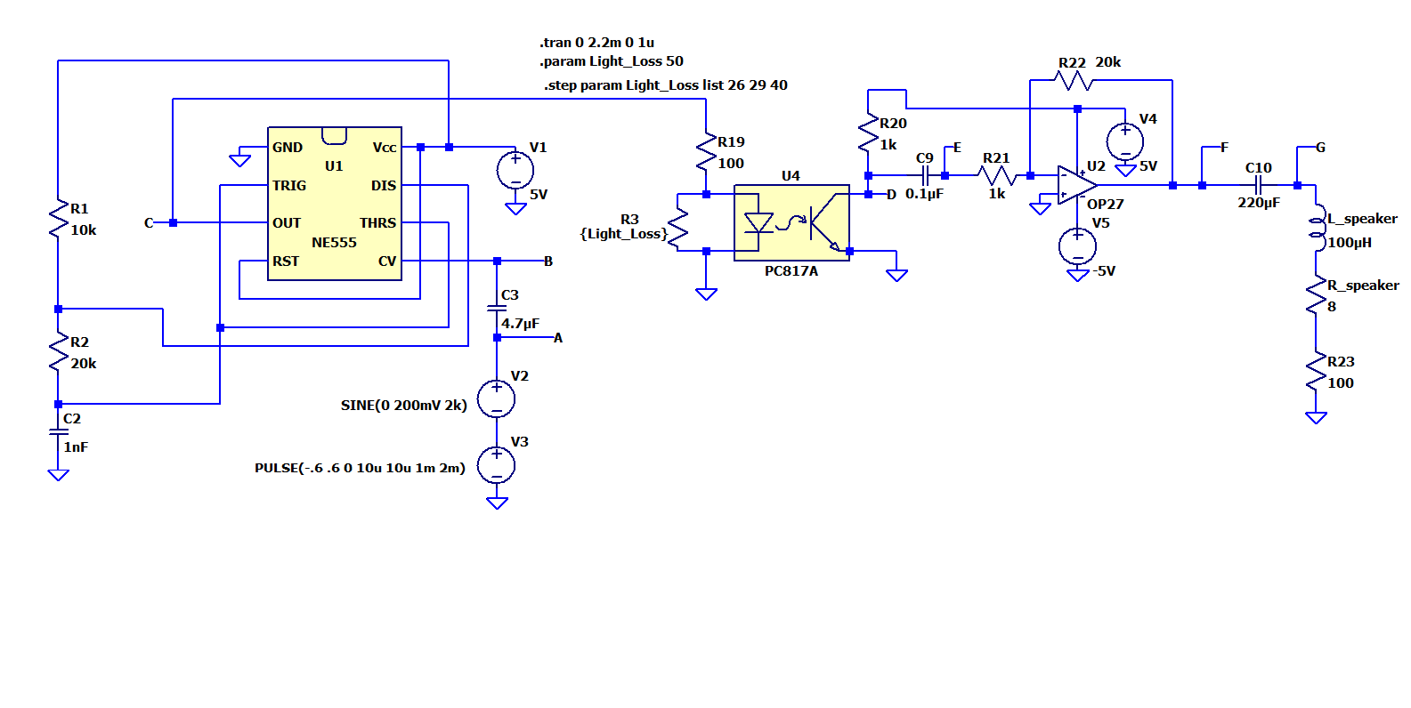

Models Audio

Signal

**Figure 6. The PC817 is used to provide a model of the optical link. You build the circuit using the IR LED and the photo transistor.**

*The model:* Figure 6 shows the LTspice model. An audio source is approximated using a small sine wave at 2kHz, V2, and a square wave at 500Hz, V3. This helps demonstrate how the circuit works. For some measurements run the simulation with only one source on at a time. The transmitter circuit is separated from the receiver circuit by using a PC817 optical link in the model. (In the circuit that you build in hardware, this is the IR led and the phototransistor with an air gap through which the light pulses are transmitted.)

**The model has a resistor to represent the light that isn’t coupled in the physical circuit. This is R3 in Figure 6.** The current through R19 is split between R3 and the LED of the PC817. A smaller R3 will divert more of the current and result in less signal coupling. This is the same as miss aligning the LED and photo transistor, the more misaligned the more light that is lost. The LTspice simulation is set to run with 3 values of R3 to represent different levels of misalignment. **You should choose 1 value of R3 to complete the modelling but return to this issue when you compare your physical circuit to the model.** The value you choose doesn’t need to be one of the ones presently in the .step command (26, 29 and 40 Ohms). You can pick your own value.

**The figure also shows the locations you will use to add the circuit elements you need for your final design.**

*Run the simulation:* Start by running the simulation provided on the course website. **It is recommended that you modify the simulation statement to start collecting data at 4ms and collect about 8ms of data. This avoid some of the startup transients.** Remember that the initial design should give you a poor quality reproduction of your input signal. Therefore, you should expect the model of the initial design to give you a poor quality reconstruction of the signal at the output. The input (point A) and output (point G) of the simulation should look something like Figure 7. The figure below shows 2ms of the traces. The input trace has one cycle of the lower frequency square wave (at 500Hz) with four cycles of the higher frequency wave (at 2kHz) superimposed on it. As you can see, the output shows some of the features of the input, but it is dominated by the high frequency samples taken by the 555 timer oscillating between about minus 5V and plus 5V. Note that the average of the signal when the input is positive is less than the average when the input is negative. It is the average that carries most of the sampled information from the input.

Input Negative

Input Positive



**Figure 7.** Input and output traces. Technically the output should be only the voltage across the speaker while this includes the R23 100Ω resistor. Including the resistor increases the output amplitude but has little effect on the shape of the trace. **(This trace is from Orcad Capture and starts collecting data at t=0 so your plot will look slightly different.)**

*Determine your sampling frequency:* The sampling frequency in the LTspice model is representative of a good sampling frequency for your circuit. It is hard to determine exactly what this frequency is by looking at the pulses because the frequency of the pulses changes with the input signal. You can get a reasonable estimate by averaging over 4ms of samples in Figure 7 or by reducing the amplitudes of the signal source, V2 and V3.

**In the physical circuit there is a potentiometer, Rpot, that allows you to change the sampling frequency by changing R1 of Figure 6 over a range of 1k to 51kΩ You should try a few settings of the potentiometer on the physical circuit. You should then change the value of R1 in the simulation to get a better match of the sampling frequency between your physical circuit and the simulation.**

*Examine the different blocks:* **Once you have the simulation running, look at point D and pick one value for R3** and look at the output of each block separately. Look closely at the wave shapes. (For example, look at the signals at point A and point B only. Which one has the DC offset and why?) This will give you an idea of what the block is doing and also what to expect from the circuit you build in hardware. **Also, it is generally easier to identify the function of each block by observing what happens to the signals with only the square wave or only the sinewave input at one time. You can do this by setting one of the voltages to zero, but leaving the source in the circuit for future use. The square wave input is especially helpful in demonstrating that it is the average of the sampled output that matters.**

**Note:** **The next task is to build the transmitter and receiver in hardware. Use your hand-drawn diagrams figures 2 and 3. Figure 4 doesn’t show the IR diode or IR transistor.**

**Building and Testing the Circuits**:

Build the two circuits as shown in the circuit diagrams, your hand drawn diagrams.

* **The Rpot is a potentiometer, a variable resistor. It is recommended that you look at the output of the 555 timer and adjust Rpot, turn the center, to achieve a similar frequency as the LTspice simulation. On the next page of this document you are instructed to change this setting.**
* The circuit doesn’t have a volume control but you can change the gain by changing R22, a larger value creates a higher gain but likely more distortion. You might consider replacing R22 with another potentiometer to make it a volume control.
* The OP-27 isn’t designed to drive a speaker load, so the volume will be low. You might be able to increase the volume slightly by changing R23 to 68Ω or 47Ω but it might be at the cost of greater distortion.
* Test your circuit using a square wave signal from the function generator representative of an audio wave. You may want to also try a sine waveform, and try changing the frequency.

***Test input signal:*** The transmitter is a 555 timer circuit very similar to an astable multivibrator. The only difference is that instead of generating a regular string of pulses, it generates a string of pulses which vary in frequency in response to the input signal at pin 5. It is best to use a square wave to debug this circuit. A typical audio signal is pictured in Figure 8. Note that the signal below has several frequencies. You can see a small amplitude signal with about 10 cycles in a 5ms division, or 2kHz. There are also lower frequency oscillations. Note that the amplitude reaches a maximum of about 800mVp-p. Our circuit works best with a slightly larger amplitude, **so set the function generator to 1.2Vp-p (amplitude of 0.6V), sine or square wave at 1.5kHz.**

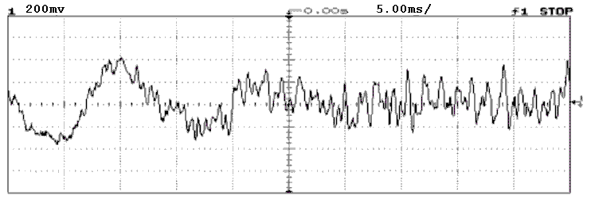

**Figure 8.**

***No common ground****:* In an ideal world the transmitter and receiver would be built on separate boards and use separate power sources with no wire connections between the transmitter and the receiver. Such a set up would clearly show that the light link carries the signal. This could be done using 2 batteries to power the receiver but you don’t need to do that this semester. You will have a common ground. The +5V source is also used by both transmitter and receiver circuits. ***In person teams*** *have the option to build the transmitter on one board using one M2k and the receiver on another using a different M2k, this will clearly show that the signal was transmitted by light.*

You are required to layout the transmitter on one end of your protoboard and the receiver on the other so that a picture can show a clear separation between transmitter and receiver. At the middle will be the IR LED connected to the 555 timer facing the IR transistor of the receiver. Refer to Experiment 8 for IR LED and phototransistor.

***Orientation of the phototransistor****:* The phototransistor has the flat side near the emitter lead which is connected to ground. The collector goes toward the resistor. Refer to Experiment 8 part C if you are uncertain on the layout.

***Verify that the transmitter is working****:* You should make sure that the pulses from your circuit are modulated by observing the voltage at the input (point A) and the voltage at the output (point C). The output should look like a pulse modulated signal. (If the input is low, the pulses should get closer together and if the input is high, the pulses should get farther apart.) As you turn the pot, the frequency of your output pulse modulated signal should change.

***Set your sampling frequency****:* CD quality sound uses 44.1k samples per second to recreate an audio signal. We will use a somewhat lower frequency so the sampling effects will be clearer. Each pulse in your modulated signal is like a digital sample. A high sampling rate is desirable if you want to get high quality sound from your circuit. The sampling rate should also be higher than the range of audible frequencies so that you cannot hear any artifacts from the sampling**. To vary your sampling rate, turn the 50K pot.** To determine your sampling frequency, find the frequency of the pulses using the scope. You should turn off the Signal Generator to see natural frequency of the 555 timer circuit. When you run a signal you will not be able to get an exact measure of the sampling frequency of your circuit because it changes but you can get an estimate by averaging over several cycles. Since you will be comparing your data to the LTspice model (and using it to design your integrator), it is important that the sampling frequencies for your actual circuit and your LTspice circuit match fairly well. **If you have a working circuit, adjust the LTspice model to match the frequency of the circuit by changing the value of R1**.

***A working receiver****:* If yours does not work, try debugging it in pieces. Check to see that the phototransistor is generating a set of pulses that correspond to the pulses from the LED. Check to see that the inverting amplifier is making the pulses bigger. If you identify a block that does not work, debug it before you continue on to the next one. A TV remote can be used as a test signal, turn off the signal generator and aim a remote at the photo transistor, hold down the on/off button.

***Your audio signal:*** You will need to demonstrate that your circuit works by using the function generator and then an audio signal. Your laptops have audio output jacks. You can bring your own music or find some on the internet. If you prefer, you can use your portable audio device. **Probably the most flexible option is to use the Analog Discovery *Wavegen* or the M2k Signal Generator.** You can load a .wav file into either device. This allows you to control the audio level. Notes about the M2k: The file size needs to be limited but files of 5 sec work, files of 5 minutes don’t. When changing the amplitude in the M2k, stop the Signal Generator first, change the amplitude and then restart the Signal Generator.

**If you choose to load a .wav file onto your M2k/Analog Discovey read the instruction file on the course website** (***Using Wave Files in Wavegen***, found under Analog Discovery Information or ***Using Wave Files in the M2k,*** found with the M2k information on the course website). Make sure that you use the scope to check the amplitude of your input signal. Start with the volume of your signal so that it corresponds roughly to the 400mV (800mV p-p) amplitude of the test input. If you cannot turn the volume up that high, you may need to use another file. Amplitudes above 2Vp-p might interfere with the 555 timer’s ability to sample the input effectively, so only use large levels if you can’t get a good signal through the system.

If you use another device you might need 1/8” mini stereo plugs with the wires separated.

**Signature: When your circuit works, have a staff member listen to the circuit with the sine wave input and with the audio input and that they check you off.**

Taking your data

Take data showing the input to and output from each block of the circuit and also the overall function of the circuit. *All signals should be taken relative to ground.*  ***It is easiest to see how the circuit works if you use a square wave. Therefore, we ask you to take most of your data using this signal*.** YOU MAY TAKE MORE THAN ONE PICTURE OF EACH BLOCK. In some cases, it helps to take a “close-up” of the individual pulses and a “wide-angle” of the overall signal shape. Whatever data you take, make sure that the LTspice picture and the Analog Discovery/M2k picture are at about the same time scale so that they can be compared. *No signatures are required.*

***Simulation****–Obtain LTspice data:* Before you take plots of the LTspice simulation, verify that the sampling frequency is about the same as your circuit. If not, you can alter the sampling frequency by changing R1 in the simulation or turning the pot in the physical circuit.

**Plot the following pairs of points with only the sine wave input**, set the amplitude of the square wave source to zero. **Then repeat with only the square wave. For each set of plots use a 1kHz input.**

**Pair (A-B): ______ Pair(A-C): ______ Pair(A-D): ______**

**Pair (A-E): ______ Pair(A-F): ______ System(A-G): ______**

***Experiment****—Obtain function generator data:* **The following is a list of the oscilloscope plots you should generate using 1kHz a sine wave and then repeat with a 1kHz square wave signal from the function generator as input.** For each Pair put one signal on channel 1 and the other on channel 2. Be careful to keep track of which signal is which. *The speakers we have (with low impedance) may distort the output at G. If this is too great of a problem, you can remove the speaker when you take the data at point G.*

**Pair (A-B): ______ Pair(A-C): ______ Pair(A-D): ______**

**Pair (A-E): ______ Pair(A-F): ______ System(A-G): ______**

***Take audio data****:* Take the following additional data using your chosen audio signal as input. *Some of the speakers we have (with low impedance) distort the output at G. If you have this problem, you can remove the speaker when you take the data at point G.*

**Pair(E-F): ______ System(A-G): ______**

**Comparison**

The final step in the initial design is to compare the output of the LTspice model to the output of the actual circuit. Are they similar? Also examine the function of each circuit signal Pair. Does each Pair work as expected?

**Part B - Final Design**

The initial design for the receiver of this project should have reconstructed the signal well enough to be audible, but likely does a very poor job. You can improve the output of your circuit by adding an integrator and a smoothing capacitor. Your final signal (at point G) should look and sound much more like the original signal coming from your audio device (at point A).

Adding an integrator

The first change you will make to your circuit is to add an integrator.

What the integrator should do: When you integrate the modulated signal, you take advantage of the fact that the pulses vary in frequency. Your pulses (at point E) look like square waves centered around zero but with different on time compared to the off time. For the positive part of the pulse, the signal (the integration of a positive constant) ramps up. For the negative part of the pulse, the signal (the integration of a negative constant) ramps down. Since the pulses vary in frequency (and width) with the signal, adding this integration will bring out the variation in the amplitude of the original signal. Figure 9 shows the input (point A) and the output (point G) of the spice model with an appropriate integrator added. Note that you can still see the sampling pulses, but the output (which is inverted) captures the overall shape of the wave much better. You can see both the shape of the lower frequency and the higher frequency of the input. (These plots are for a pair of sine wave inputs, one at 500Hz and one at 4kHz. You can choose to do these frequencies or use the separate 1kHz sine wave and square ware signals.



**Figure 9.**

There are a few things you should note in this output. The output shown might be inverted compared to your data as this was done with an additional stage of an audio amp. You may also see a phase shift or a time shift of the output, this is caused by a phase shift induced with an integrator and by a limited frequency response of the overall circuit. These will not affect the sound quality at the speaker.

**Types of integrators:** You can either add a passive or an active integrator to your circuit. Both work well, so it is a matter of preference. Both are discussed in this section:

* Passive Integration

Figure 10 shows a passive (approximate) integrator. It only works at higher frequencies. When   
⬥ >> c = 1/RC, then . If you add this integrator, you will add it at point E.

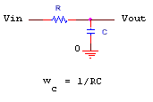

**Figure 10.**

When you add this integrator, you may notice a marked change in the amplitude of your signal. You can increase the gain by changing the R22 of figure 4. You may want to change by a factor of 5 or so.

* Active Integration

Figure 11 shows an active integrator. This can be done by modifying the circuit in figure 4 or you can add an additional op amp stage. This integrator my not work well at very low frequencies.

When  >> c = 1/(RfC), then .

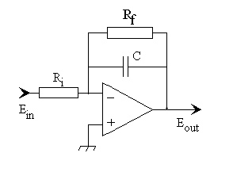

**Figure 11.**

When you add this integrator, you may notice a marked change in the amplitude of your signal. You can adjust Ri of the integrator or R22 of Figure 4 to compensate if needed.

**Integrator design:** You want your integrator to not affect a useful audio signal but to integrate (average out) higher frequencies. The higher frequencies will be part of any signal delivered to the speaker because of the pulses produced by the 555 timer in the transmitter. All unwanted signals (those that are not in the audio range of interest) are noise. In the LTspice model, the example input frequency varies between 500Hz and 4kHz. This range covers much of the range we hear in common speech and music and should adequately cover the frequencies that will not be significantly affected by the integrator. If you want to, you can look closely at the audio signal you are using and determine its lowest and highest frequencies. If they fall outside this range, change the frequencies of the two sine wave sources. With either integrator, you need to choose R and C such that your chosen corner frequency is much less than the frequencies you want to integrate, fc = 1/(2πRC) << fnoise and possibly even lower than some of the useful audio range. In the passive integrator, you can choose R arbitrarily, in the active integrator, R is the value of your feedback resistor. There is more information on integrators in the Project 4 slides and videos. You are limited because the 555 timer frequency is likely about 30kHz which isn’t that far from the audio range.

**LTspice test**: Once you have chosen an integrator and your target component values, try adding the integrator to the LTspice model. Run the simulation and see if it works. Note that you may need to change the gain, which can be done by changing R22 in figure 6. Try adjusting the value of the integrator capacitor until you get a good integration with adequate final amplitude. Remember, you don’t need to worry about the pulses from the 555 timer sampling. You just want to get a good reconstruction of the input with the sampling pulses superimposed on it as shown in Figure 9.

**The hardware integrator:** After you have used LTspice to design an integrator, add the integrator to your circuit. Don’t forget to also add any other changes you made in the LTspice model (like amplifying the signal). Does your integrator work? Many times the best design predicted by LTspice will not be the one that works optimally in your circuit. If you find a design that works better in the actual circuit, go back and adjust the LTspice simulation.

**Signature: When your circuit works as expected with the integrator, have a staff member listen to the circuit with the sine wave for your check off.**

**Take your data:** When you have a working integrator, take an oscilloscope picture of the integrator functioning and the overall performance of the circuit and the model with a sine wave input. You are allowed to invert the output if that makes it easier to compare to the input. Again, the speakers may distort the output at G. If you have this problem, you can remove the speaker when you take the data at point G.

LTspice output: **Pair(E-F): ______ System(A-G): ______**

Circuit with sine wave input: **Pair(E-F): ______ System(A-G): ______**

**Switch the input to an audio signal and have a staff member listen to the circuit with the audio signal for your check off.**

**Take your data with the audio signal:** When you have a working integrator, take an oscilloscope picture of the integrator functioning and the overall performance with the audio signal. You are allowed to invert the output if that makes it easier to compare to the input. Again, some of the speakers we have (with low impedance) distort the output at G. If you have this problem, you can remove the speaker and when you take the data at point G.

Circuit audio input: **Pair(E-F): ______ System(A-G): ______**

**Smoothing out the sampling frequency - this is optional and can qualify for up to10 bonus points if done very well. No points for just adding a capacitor and not showing and explaining improvements in the signal.**

The (optional) final addition to your circuit is to add a smoothing capacitor to eliminate the pulses created by the sampling.



**Figure 12.**

What the smoothing capacitor should do: Recall that when you added a smoothing capacitor to the output of a rectifier, the bumps from the rectified signal were smoothed over and the output was much more even. You can apply this concept to the signal in this circuit as well. If we add a smoothing capacitor of the correct size between point F and ground, we should be able to smooth out the pulses caused by the sampling and come up with an even closer reconstruction of the original audio wave. Figure 12 shows the result of adding a smoothing capacitor to the integrated signal. It shows the original input (at point A), the output of the circuit (at point G), and the inversion of the output (at point G). Note that the original input frequencies have been preserved, but the pulses (that are shown in Figure 9) have been largely eliminated. Aside from a change in amplitude, a slight time delay, and some inconsistencies in DC offset (caused by the integration), the input and the output are now very much the same. You can see that this is a substantial improvement over the initial data shown in Figure 7.

What capacitance should I use? The exact value of your smoothing capacitor will depend on your integrator and your sampling frequency. A capacitor that is too large will smooth over the high frequencies of your input signal. A capacitor that is too small will not smooth over the sampling pulses. Try experimenting with the LTspice model by adding a 1μF capacitor between point F and ground. Look at the output. Should the capacitance be increased or decreased? Increase or decrease the capacitance in increments of an order of magnitude (0.001μF, 0.01μF, 0.1μF, 1μF, 10μF, 100μF, 1000μF) until you find one that gives you the best reconstruction. You can then fine tune the capacitance using the values you have in your kit. If you find you need a capacitance that you do not have you can consider using a series/parallel configuration.

Circuit Instabilities: As you try larger values of capacitance, it is likely that an instability will occur manifested by the appearance of additional wiggles in the signal. This is similar to the instability we observed in the differentiator circuit and do to the same cause (additional phase shift in the feedback). If you observe such an artifact in your data, you have two options to deal with it. First, you can reduce the value of your smoothing capacitor until the instability disappears. If the signal still looks good (very little residue from the square sampling pulses), then your smaller capacitance is fine. If, however, you need more smoothing, you can add a small resistor (10-50Ω) between point F and where you connect the capacitor. That is, after point F you should have a small series resistor, then a capacitor to ground (your smoothing capacitor).

Check the smoothing capacitor in your circuit: We have found that the smoothing capacitors do not always work well in the actual circuit. Try adding the smoothing capacitor to your circuit and see if it works. You may need to try a slightly different size capacitor than the one predicted by LTspice. **If you can find a design that both integrates and smoothes the signal, take a scope picture of the output for a sine wave input signal and have it signed by a staff member. Include it for extra credit.** Make sure you indicate what components you used to get the circuit working.

Take your LTspice data: Once you have decided on a smoothing capacitor that works well in LTspice, take your data. If you want, in System(A-G), you can invert the output at G with the scope and with LTspice to get a better visual comparison to the input at A.

LTspice output: **Pair(E-F): ______ System(A-G): ______**

Take your circuit data:

If you were able to get the smoothing capacitor to work, take this last picture with both the integrator and the smoothing capacitor. If you did not, take it with only the integrator. The speakers we have (with low impedance) will distort the output at G. If you have this problem, you can remove the speaker and when you take the data at point G.

Final circuit with audio source input: **Pair(E-F): ______ System(A-G): ______**

**Signature: When your circuit works as expected with the integrator and the smoothing capacitor have a staff member listen to the circuit with the audio input for check off.**

**If you have the smoothing capacitor, indicate that to the staff member.**

**Part C - The Report**

Instead of a formal report this semester, we are asking you to provide the following packet. Basically, we want you to show a caparison between the LTspice output and the output from the circuit. You will be graded out of 70 points for the packet plus an additional 10 point general assessment. If you want you can include more than one pair of plots for any Pair. Also Include the cover/signature page attached to the end of this handout. ALL PLOTS SHOULD INDICATE WHICH TRACE CORRESPONDS TO THE SIGNAL AT WHICH POINT. Based on your simulation and experiment, identify and discuss any performance limitations of your system.

A. Plots for Initial Design with Function Generator Input (40 points)

Two cases – 1kHz sine and square wave.

Part A1: Pair A-B

* Output from LTspice (1 pt)
* Output from circuit (1 pt)
* Pair description and brief comparison (3 pt)

Part A2: Pair A-C

* Output from LTspice (1 pt)
* Output from circuit (1 pt)
* Pair description and brief comparison (3 pt)

Part A3: Pair A-D

* Output from LTspice (1 pt)
* Output from circuit (1 pt)
* Pair description and brief comparison (3 pt)

Part A4: Pair A-E

* Output from LTspice (1 pt)
* Output from circuit (1 pt)
* Pair description and brief comparison (3 pt)

Part A5: Pair A-F

* Output from LTspice (1 pt)
* Output from circuit (1 pt)
* Pair description and brief comparison (3 pt)

Part A6: Pair A-G

* Output from LTspice (3 pt)
* Output from circuit (3 pt)
* Pair description and brief comparison with discussion on results (9 pt)

B. Plots for Initial Design with Audio Input (6 points)

Part B1: Pair E-F

* Output from circuit (3 pt)

Part B2: Circuit Function A-H

* Output from circuit (3 pt)

C. Final Design with Integrator only (18 points)

Part C1: Final design schematic

* Print out of final design schematic from LTspice (3 pt)
* Calculation of corner frequency of integrator (3 pt)

Part C2: Pair E-F – Function Generator Input (both sine and square wave)

* Output from LTspice (2 pt)
* Output from circuit (2 pt)
* Brief comparison (2 pt)

Part C3: Circuit Function A-H – Function Generator Input (both sine and square wave)

* Output from LTspice (2 pt)
* Output from circuit (2 pt)
* Brief comparison (2 pt)

Part C4: Circuit Function A-G – Audio Input

* Output from circuit (3 pt)
* Brief comparison (3 pt)

D. Final Design with Integrator and Smoothing Capacitor (extra credit, up to 10 points)

The points will be assigned based on a demonstration of an improved signal, documentation of the circuit, and a discussion of how the signal is improved. Typically this requires a schematic, signal traces with and without the smoothing capacitor, and an effort to quantify the improvement. Typically it requires demonstrating using both the LTspice simulation and the physical circuit. Since this is extra credit a detailed list of point assignments will not and can not be provided here.

**Total: 70 points for project packet**

**+10 points for general assessment of packet**

**+20 points for attendance**

**100 points**

**Attendance (20 possible points)**

**3 classes (20 points), 2 classes (10 points), 1 class (0 points)**

**Minus 5 points for each late.**

**No attendance at all = No grade for project.**

Here is an example of an appropriate “block (signal pair) description” and “brief comparison”

Block Description: Block E-F amplifies the signal from the phototransistor. As you can see, in both the LTspice simulation and the actual circuit output, the output signal (the trace marked F) is larger than the input signal (the trace marked E). The output and the input are the same basic shape and the frequencies are preserved exactly. The amount of gain can be increased by replacing R22 with a larger value or decreased by using a smaller value. For this circuit a value of xxx Ohms was found to work well.

Brief Comparison: For the initial design the LTspice output and the output from the circuit have comparable sampling frequency (around 48kHz). The overall shape of the output of both (triangular samples superimposed over a signal which marginally represents the input) are comparable. R3, the light loss resistor, in the LTspice simulation was set to a value of xx Ohms so that the amplitude of the signals at point D are about the same for both LTspice and the actual circuit, as is discussed in the Block C-D Description.

**Project 4**

**Electronic Instrumentation**

**Section: ______**

**Report Grade: ______**

|  |  |
| --- | --- |
| **Name:** | **Name:** |
| **Name:** | **Name:** |

**Signatures**

1. **Hand-Drawn Circuit Diagrams ___________________________**
2. **Initial Design**

**Function Generator Input ____________________________**

**Audio Input _______________________________________**

1. **Final Design with Integrator Only**

**Function Generator Input ____________________________**

1. **Final Design with Integrator**

**Audio Input _______________________________________**

**Note: Every team must have a signature for part 4. All teams must have an integrator circuit and demonstrate with an audio input. Extra credit is offered if and only if a smoothing capacitor is added and the report can show a reduction in noise without a reduction in the signal.**

1. **Extra credit: Final Design with Integrator and smoothing capacitor  
     
    Audio Input ________________________________________**