Experiment 4

**Op-Amp Circuits**

**Purpose:** In this experiment, you will learn about operational amplifiers (or op-amps). Simple circuits containing operational amplifiers can be used to perform mathematical operations, such as addition, subtraction, and multiplication, on signals. They can also be used to take derivatives and integrals. Another important application of an op-amp circuit is the voltage follower, which serves as an isolator between two parts of a circuit.

Background: Before doing this experiment, students should be able to

* Analyze simple circuits consisting of combinations of resistors, inductors and capacitors
* Do a transient (time dependent) simulation of circuits using *LTspice*
* Do an AC analysis (frequency dependent) simulation of circuits using *LTspice*, determining both the magnitude and the phase of input and output voltages.
* Build simple circuits on protoboards and measure input and output voltages vs. time.
* Review the background for the previous experiments.

Learning Outcomes: Students will be able to

* Connect an op-amp chip (DIP package) in a standard configuration on a protoboard (signal and power)
* Investigate the performance of standard inverting and non-inverting op-amp circuits three ways:
  + Determine the gain of standard inverting and non-inverting op-amp circuits
  + Simulate the operation of standard inverting and non-inverting op-amp circuits using *LTspice*
  + Experimentally determine the gain of standard inverting and non-inverting op-amp circuits
  + Identify operating conditions under which practical op-amps operate close to their ideal predictions.
* Investigate standard op-amp voltage followers (but no physical experiment).
* Investigate the performance of standard op-amp integrators and differentiators following the same approach as with inverting and non-inverting amplifiers.
  + Build and analyze practical integrators (aka Miller Integrators) that operate like their ideal counterparts
  + Build and analyze practical differentiators that operate like their ideal counterparts
* Investigate op-amp adders (but no physical experiment).
* Perform basic mathematical operations on electrical signals using op-amp circuits.

Equipment Required:

1. **M2K** (with Scopy Software)
2. **DC supplies** (M2K)
3. **Analog I/O** ( M2K)
4. Protoboard
5. Some Resistors
6. OP27 op-amp

***Note that there is no special equipment required for this experiment, so the work can be done anywhere. You still have to get checked off in class, but you have a lot of flexibility in where you complete most of the tasks.***

Helpful links for this experiment can be found on the ***Links by Experiment*** page for this course. Be sure to check out the key links and at least glance through the entire list for this experiment. It is particularly important to completely read, and keep handy, the handout on ***Integrators and Differentiators***.

**Pre-Lab**

*Required Reading:* Before beginning the lab, at least one team member must read over and be generally acquainted with this document and the other **required reading** materials listed under [Experiment 4](http://www.ecse.rpi.edu/courses/F21/ENGR-2300/EILinks.html#Exp4) on the EILinks page.

*Hand-Drawn Circuit Diagrams:* Before beginning the lab, hand-drawn circuit diagrams must be prepared for all circuits physically built and characterized using your M2K board.

**Part A – Introduction to Op-Amp Circuits**

**Background**

*Elements of an op-amp circuit*: Figure A-1 below is a schematic of a typical circuit built with an op-amp.

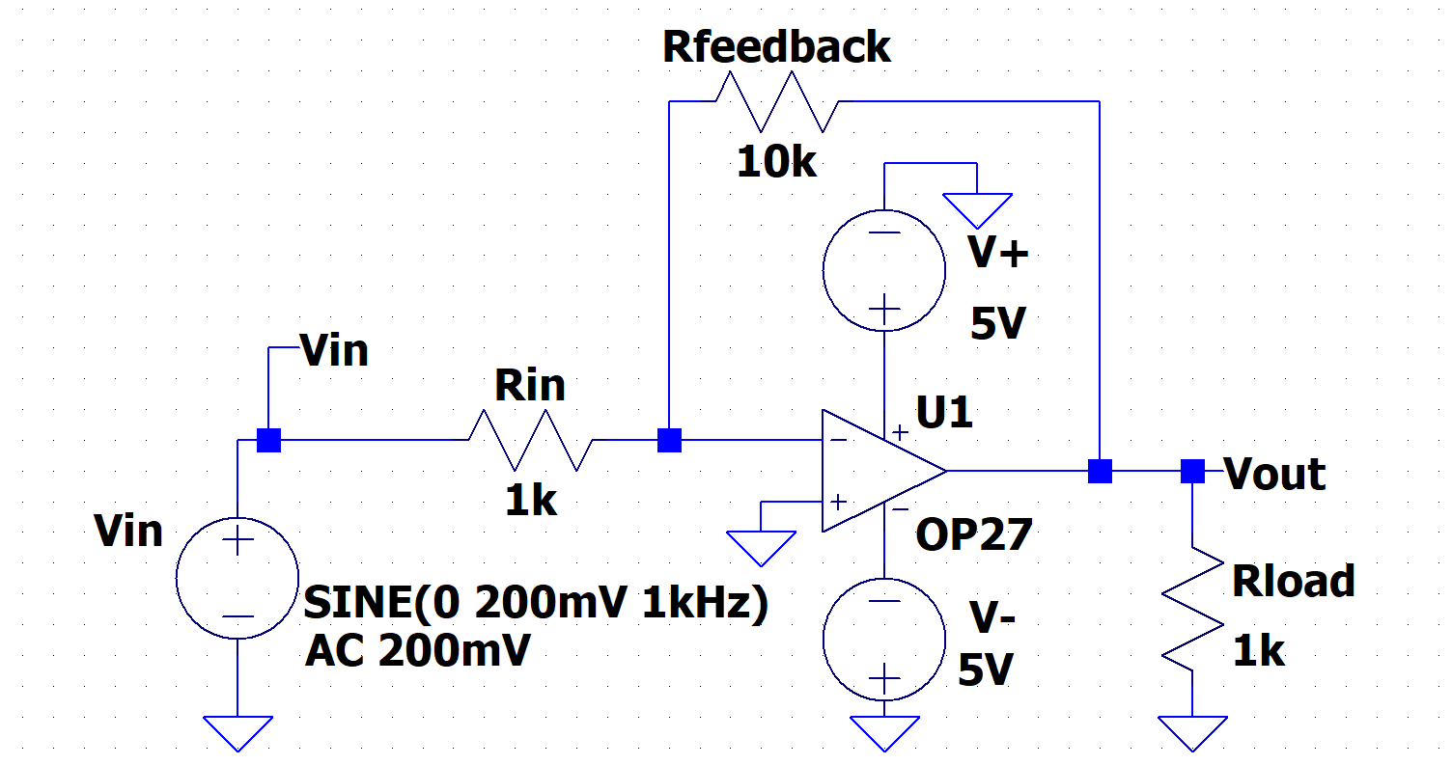

**Figure A-1. Drawn with the OP-27 op-amp (Rload ≈ 1kΩ).**

The circuit performs a mathematical operation on an input signal. This particular op-amp circuit will invert the input signal, Vin, and make the amplitude 10 times larger. This is equivalent to multiplying the input by -10. Note that there are two DC voltage sources in addition to the input. These two DC voltages power the op-amp. The circuit needs additional power because the output is bigger than the input. Op-amps always need power sources. The two resistors Rfeedback and Rin determine how much the op-amp will amplify the output. If we change the magnitude of these resistors, we do not change the fact that the circuit multiplies by a negative constant; we only change the magnitude of the multiplier. The load resistor Rload is not part of the amplifier. It represents the resistance of the load on the amplifier.

*Powering the op-amp*: The two DC sources, (labeled asV+ and V-, but also often labeled as ± VCC), that provide power to the op-amp are typically set to have an equal magnitude but opposite sign with respect to the ground of the circuit. This enables the circuit to handle an input signal which oscillates around 0V, like most of the signals we use in this course. (Note the signs on the sources in the circuit above.) The schematic in Figure A-2 shows a standard ± VCC configuration for op-amps. These are dc sources. They are not signal sources. Vin is the signal source.

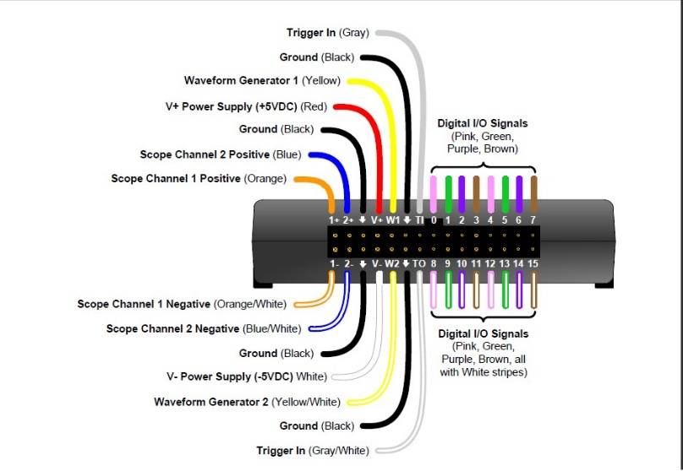

V+

V-

**Figure A-2.**

***For this version, we use the +5V and -5V supplies on the M2K, red and white wires.***

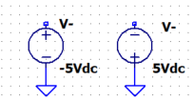Note that in *LTspice*, there are two ways to represent a source with a negative sign. Figure A-3 shows the two options: you can either set the voltage source to a negative value, or you can reverse the polarity of the source.

**Figure A-3. Both sources will provide -5V**

*The op-amp chip:* Study the chip layout of the OP27 op-amp shown in Figure A-4. (The uA741 has a slightly different pin-out, but in simulation that won’t matter.) The standard procedure on DIP (dual in-line package) "chips" is to identify pin 1 with a notch in the end of the chip package. The notch always separates pin 1 from the last pin on the chip. Pin 2 is the inverting input. Pin 3 is the non-inverting input, and the amplifier output, VO, is at pin 6. These three pins are the three terminals that normally appear in an op-amp circuit schematic diagram. The +VCC and ­VCC connections (7 and 4) MUST be completed for the op-amp to work, although they usually are omitted from simple circuit schematics to improve clarity.

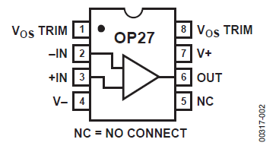

**Figure A-4.**

The balance (or null offset) pins (1 and 8) provide a way to eliminate any offset in the output voltage of the amplifier. The offset voltage (usually denoted by Vos) is an artifact of the integrated circuit. The offset voltage is additive with VO (pin 6 in this case). It can be either positive or negative and is normally less than 10mV. Because the offset voltage is so small, in most cases we can ignore the contribution VOS makes to VO and we leave the null offset pins open. Pin 5, labeled "NC", has no connection to the internal circuitry of the OP27, and is not used.

*Op-amp limitations*: Op-amps have limitations that prevent them from performing optimally under all conditions. The one you are most likely to encounter is called *saturation*. An op-amp becomes saturated if it tries to put out a voltage level beyond the range of the power source voltages, ±VCC*,* For example, if the gain tries to drive the output above 5V, the op-amp is not supplied with enough voltage to get it that high and the output will cut off at the most it can produce. This is never quite as high as 5V because of the losses inside the op-amp. Another common limitation is amount of current an op-amp can supply. Large demands for current by a low resistance load can interfere with the amount of current available for feedback, and result in less than ideal behavior. Also, because of the demands of the internal circuitry of the device, there is only so much current that can pass through the op-amp before it starts to overheat. A third limitation is called the *slew rate* and is the result of limited internal currents in the op-amp. Delays caused by the slew rate can prevent the op-amp circuit from displaying the expected output instantaneously after the input changes. The final caution we have about op-amps is that the equations for op-amps are derived using the assumption that an op-amp has infinite intrinsic (internal) gain, infinite input impedance, zero current at the inputs, and zero output impedance. Naturally these assumptions cannot be true, however, the characteristics of real op-amps are close enough to the assumptions that circuit behavior is close to ideal over a large range.

***The circuit has a greater output voltage range if 9V batteries are used rather than the 5V supplies.***

*The inverting amplifier:* Figure A-5 shows an *inverting amplifier*.

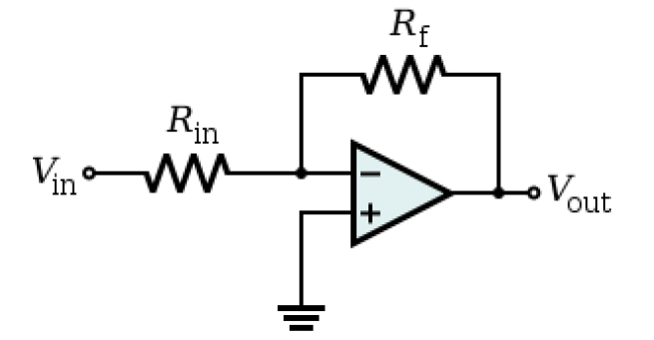

**Figure A-5.**

Its behavior is governed by the following equation: . The negative sign indicates that the circuit will invert the signal. (When you invert a signal, you switch its sign. This is equivalent to an180° phase shift of a sinusoidal signal.) The circuit will also amplify the input by Rf/Rin. The total gain for this circuit is –(Rf/Rin). Note that most op-amp circuits invert the input signal because op-amps stabilize when the feedback is negative. **Also note that even though the connections to V+ and V- (±VCC) are not shown, they must be made in order for the circuit to function in both *LTspice* and on your protoboard.**

*The non-inverting amplifier*: Figure A-6 shows a *non-inverting amplifier*. Its behavior is governed by the following equation: .

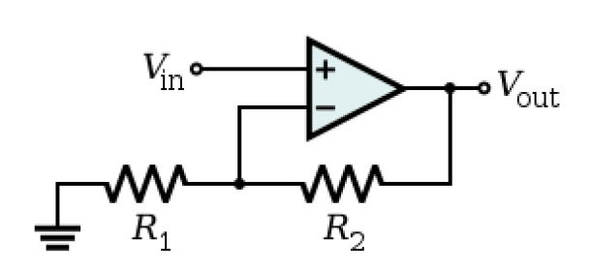

**Figure A-6.**

This circuit multiplies the input by 1+(R2/R1) and, unlike the previous op-amp circuit, the output is not an inversion of the input. The overall gain for this circuit is, therefore, 1+(R2/R1). The inverting amplifier is more commonly used than the non-inverting amplifier. That is why the somewhat odd term “non-inverting” is used to describe an amplifier that does not invert the input. If you look at the circuits, you will see that in the inverting op-amp, the chip is connected to ground, while in the non-inverting amplifier it is not. This generally makes the inverting amplifier behave better. When used as a DC amplifier, the inverting amp can be a poor choice, since its output voltage will be negative. However, for AC applications, inversion does not matter since sines and cosines are positive half the time and negative half the time anyway. **Again, note that even though the connections to V+ and V- (±VCC) are not shown, they must be made in order for the circuit to function in both *LTspice* and on your protoboard.**

**Experiment**

*The Inverting Amplifier*

In this part of the experiment, we will wire a very simple op-amp circuit using *LTspice* and look at its behavior. The OP27 is in the Opamps library but you should see it if you type op27 component selection box. Wire the circuit shown in Figure A-7 below in *LTspice*.

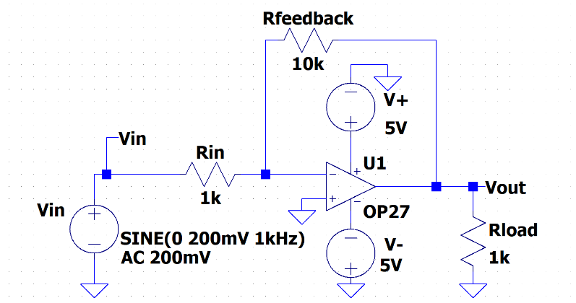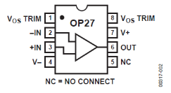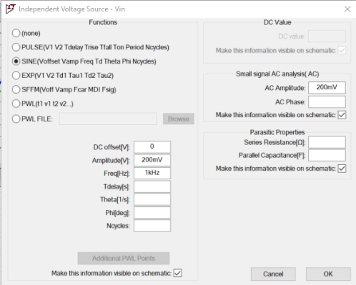

**Figure A-7.**

* + The input should have 400mV pk-pk amplitude (200mV pk amplitude), 1kHz and no DC offset.
  + The op-amp is called the OP27. It is in the [Opamps] folder for LTspice components.
  + Be careful to make sure that the + and – inputs are not switched and that the two DC voltage supplies have opposite signs.
  + Label Vin on the wire between the signal source and Rin. Label Vout.
* Run a transient simulation of this circuit that displays three cycles (three periods).
  + What does the equation for this type of circuit predict for its behavior?
  + Use the cursors to mark the amplitudes of the input and output of the circuit.
  + Calculate the actual gain on the circuit. Is this close to the gain predicted by the equation?
  + Copy this plot and include it with your report.
* Run a transient of the circuit with a much higher input amplitude.
  + Change the amplitude of the source to 1V and rerun the simulation.
  + What does the equation predict for the behavior this time? Does the circuit display the output as expected? What happened?
  + Use the cursors to mark the maximum value of the input and output of the circuit.
  + What is the magnitude of the output of the circuit at saturation?
  + Copy this plot and include it with your report.

*Build an Inverting Amplifier*

Now you will build an inverting amplifier. Build the circuit using the OP27 op-amp in your Parts kit. Use V+ (red wire) and V- (white wire) of the M2K. **Enable the power supplies only after you confirm your wiring. You can burn out the chip.**



**Figure A-7 (repeat)**

* Build the inverting op-amp circuit in Figure A-7 on your protoboard.
  + Don’t neglect to wire the DC power voltages at pins 4 and 7. Do not connect either pin 4 or 7 to ground (Black). Follow the power connection guide on page 2. Remember to enable the power supplies.
  + Remember to use Oscilloscope Channel 1+ (Orange), Oscilloscope Channel 2+ (Blue) for the two voltage measurements and Waveform Generator W1 (Yellow) as your source. Also, connect M2K ground and the negative leads (1- & 2-) for channels 1 & 2 to circuit ground.
* Examine the behavior of your circuit.
  + Take a picture with the M2K Oscilloscope display of the input and output of the circuit at 1kHz and 400mV(p-p) amplitude and include it in your report. Always measure both input and output, even when you are not specifically asked to.
  + What was the gain of your circuit at this amplitude and frequency? [Use the signals to calculate the gain, not the values of the resistors.]
  + Saturation: Vary the amplitude of the Signal Generator until the op-amp output starts to saturate. At about what input amplitude does this happen? What is the magnitude of the output of the circuit at saturation? How does this compare with the saturation voltage found using *LTspice*? Does it saturate at the same positive and negative voltage?

**Summary**

As long as one remains aware of some of their limitations, op-amp circuits can be used to perform many different mathematical operations. That is why collections of op-amp circuits have been used in the past to represent dynamic systems in what is called an analog computer. There are some very good pictures of analog computers and other computers through the ages at H.A. Layer’s Mind Machine Web Museum. A link is located on the course links page.

**Part B – Voltage Followers**

**Background**

*The voltage follower:* The op-amp configuration in Figure B-1 is called a *voltage follower* or *buffer*. Note that the circuit above has no resistance in the feedback path. Its behavior is governed by the equation: .

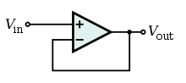

**Figure B-1.**

If one considers only the equation , this circuit would appear to do nothing at all. In circuit design, however, voltage followers are very important and extremely useful. What they allow you to do is completely separate the influence of one part of a circuit from another part. The circuit supplying Vin will see the buffer as a very high impedance, and (as long as the impedance of the input circuit is not very, very high), the buffer will not load down the input. (This is similar to the minimal effect that measuring with the Oscilloscope has on a circuit.) On the output side, the circuit sees the buffer as an ideal source with no internal resistance. The magnitude and frequency of this source is equal to Vin, but the power is supplied by ± VCC. The voltage follower is a configuration that can serve as an impedance matching device. For an ideal op-amp, the voltages at the two input terminals must be the same and no current can enter or leave either terminal. Thus, the input and output voltages are the same and Zin = Vin/Iin → ∞. In practice Zin is very large which means that the voltage follower does not load down the source.

**Experiment**

*A Voltage Follower Application*

In this part, we will investigate the usefulness of a voltage follower using *LTspice*.

* Begin by creating the circuit pictured in Figure B-2 below in *LTspice*.

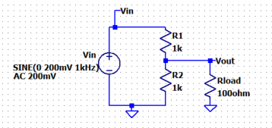

**Figure B-2.**

* + The source has amplitude of 200mV and a frequency of 1kHz.
  + The impedance of the Signal Generator is assumed to be negligible and has been left out.
  + R1 and R2 are expected to be a voltage divider and Rload is the load on the voltage divider.
* Run a simulation that displays three cycles of the input.
  + Run the simulation, mark the amplitude of the voltages shown, and copy the plot for your report.
  + If we combine R2 and Rload in parallel, we can demonstrate that the amplitude of the output is correct for this circuit. (Similar to experiment 1 with the 1MegΩ resistors.)
  + What if our intention when we built this circuit was to have the input to the 100Ω resistor be the output of the voltage divider? i.e. We want the voltage across the load (Rload) to be ½ of the input voltage. Clearly the relationship between the magnitudes of the 100Ω resistor and the 1kΩ resistor in the voltage divider will not let this occur. A voltage follower is needed.
* Modify the circuit you created by adding an op-amp voltage follower between R1 and R2, as shown in Figure B-3:



**Figure B-3.**

* + The op-amp is called OP27. It should be selected if OP27 is typed in the component search box.
  + Be careful to make sure that the + and – inputs are not switched and that the two DC voltage supplies have opposite signs. Note that we often flip the op amp for convenience but not in this case, yet.
* Run this modified simulation
  + Label the traces as shown, Vin, Vsignal, and Vout.
  + Run the Figure B-3 simulation, plot the voltage traces for the labelled points and mark the amplitudes on the plot. Copy the plot for your report.
  + What is the voltage across the 100Ω load now? Have we solved our problem?
  + The voltage follower has isolated the voltage divider electrically from the load, while transferring the voltage at the center of the voltage divider to the load. Because every piece of a real circuit tends to influence every other piece, voltage followers can be very handy for eliminating these interactions when they adversely affect the intended behavior of our circuits.
  + It is said that the voltage follower is used to isolate the load from the signal. From your results, can you explain what that means?
* Voltage followers are not perfect. They are not able to work properly under all conditions.
  + To see this, change Rload to 1Ω.
  + Rerun the simulation, mark the amplitude of the voltages shown, and copy the plot for your report.
  + What do you observe now? Can you explain it? Refer to the spec sheet for the OP27 op-amp on the links page, look at Figure 28. *Short-Circuit Current vs. Time*. How have we changed the current through the chip by adding a smaller load resistance?
* Finally, it was noted above that the input impedance of the voltage follower should be very large. Determine the input impedance by finding the ratio of the input voltage to the input current for the follower.
  + Return the value of Rload back to the original 100Ω.
  + It is best to run a frequency scan to find the input impedance since it isn’t pure real. Real op amps have an effective input resistance and input capacitance.
    - Right click on the .tran statement and choose AC Analysis, Decade, 100 points per decade, start frequency of 1Hz and stop frequency of 1e4Hz.
    - If you haven’t already labelled the Vsignal on your schematic do so now.
  + Run the simulation.
    - Recall that Z=V/I where V and I are phasors. The voltage of interest is Vsignal in Figure B-3. The current is the current into non-inverting input of the op amp, the + input.
    - Click in the plot window.
      * Plot settings > Add Trace
      * Enter the expression: V(vsignal)/ Ix(U1:In+) This is Z, which has a magnitude and phase.
      * Right click on the left axis and change to a linear scale.
  + Include a schematic with your hand drawn circuits in your report. Save the plot and include it in your report. Use the cursor and determine the magnitude of the input Z at both 1Hz and 10kHz. What are the values? You may choose to change the scales. Is the impedance still very high over this frequency range?

**Summary**

The voltage follower is one of the most useful applications of an op-amp. It allows us to isolate a part of a circuit from the rest of the circuit. Circuits are typically designed as a series of blocks, each with a different function. The output of one block becomes the input to the next block. Sometimes the influence of other blocks in a circuit prevents one block from operating in the way we intended. Adding a buffer can alleviate this problem.

**Part C – Integrators and Differentiators**

**Background**

If you have not read the document on Integrators and Differentiators, please do so now. Course Website > Links by Experiment > Experiment 4 > *Differentiators and Integrators*.

*Ideal differentiator:* Figure C-1 shows an *ideal differentiator*. Its behavior is governed by the following equation: .

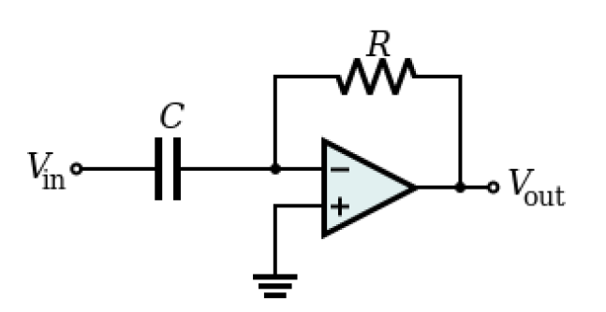

**Figure C-1.**

The output of this circuit is the derivative of the input INVERTED and multiplied by RC. For a sinusoidal input, the magnitude of the gain for this circuit depends on the values of the components and also the input frequency. It is equal to (ωRC). The circuit will also cause a phase shift of -90°. It is important to remember that there is an inversion in this circuit. For instance, if the input is sin(t), then you would expect the output of a differentiator to be +cos(t) (a +90° phase shift). However, because of the inversion, the output phase of this circuit is -90° (+90 - 180). Also note that, because one cannot build a circuit with no input resistance, there is no such thing as an ideal differentiator. A real differentiator differentiates only at certain frequencies. This distinction is discussed in the PowerPoint notes for the course.

*Ideal integrator:* The circuit shown below in Figure C-2 is an *ideal integrating amplifier*. Its behavior is governed by the following equation: .

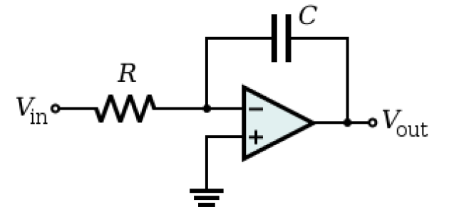

**Figure C-2.**

The output of this circuit is the integral of the input INVERTED and multiplied by 1/(RC). For a sinusoidal input, the magnitude of the gain for this circuit depends on the values of the components and also the input frequency. It is equal to 1/(ωRC). The circuit will also cause a phase shift of +90°. It is important to remember that there is an inversion in this circuit. For instance, if the input is sin(t), then you would expect the output of an integrator to be -cos(t), a -90° phase shift. However, because of the inversion, the output phase shift of this circuit is +90° (-90 + 180). Also, because the integration of a constant DC offset is a ramp signal and there is no such thing as a real circuit with no DC offset (no matter how small), wiring an ideal integrator will result in an essentially useless circuit. A Miller integrator is an ideal integrator with an additional resistor added in parallel with C. It will integrate only at certain frequencies. This distinction is discussed in the power point notes for the course.

**Experiment**

*Using an Op-amp Circuit to Integrate an AC Signal in LTspice - you will build the actual circuit later in this lab.*

In this section, we will observe the operation of a Miller integrator on a sinusoid. You will examine the way in which the properties of the integrator change both the amplitude and the phase of the output.

* In *LTspice* simulate the integration circuit shown below in Figure C-3. V1 should have a 500mV amplitude and 1kHz frequency.

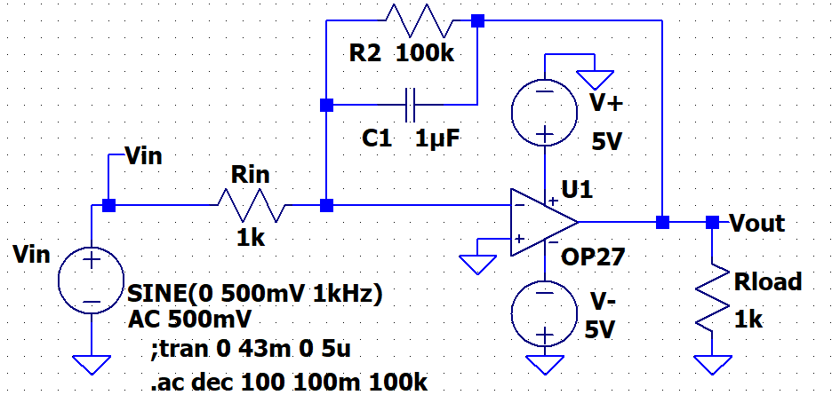

For Experiment: Connect 1+ at the point labelled Vin

For Experiment: Connect 2+ at the point labelled Vout



**Figure C-3.**

* Run a transient analysis.
  + Set up and run a Transient simulation.
    - Stop time: 43ms,
    - Time to start saving data: 0 or blank
    - Maximum Timestep: 5u and run the simulation.
    - Plot Vout and notice that you see both the natural and the forced response.
    - We want to see the response after the transients have decayed, when it is at steady state. Change the simulation to have Time to Start Saving Data: 40ms
    - You should confirm that steady-state has been reached. Steady-state means that the periodic signals are the same.
  + Obtain a plot of output and input. Just like in mathematical integration, integrators can add a DC offset to the result. Adjust your output so that it is centered around zero by adding a trace that adds or subtracts the appropriate DC value. After you have done this, determine the amplitude of your input and output with the cursors.
  + Copy this plot and include it in your report. Remember to always plot both the input and the output.
* Use the equations for the ideal integrator to verify that the circuit is behaving correctly.
  + The equation that governs the behavior of this integrator at high frequencies is given by:



* + Recall that the integration of sin(ωt) = (-1/ω)cos(ωt). Therefore, the circuit attenuates the integration of the input by a constant equal to -1/ωR1C1. The negative sign means that the output should also be inverted.
  + What is there about the transient response that tells you that the circuit is working correctly? Is the phase as expected? The amplitude? Above what frequencies should we expect this kind of behavior?
* Now we can look at the behavior of the circuit for all frequencies.
  + Change the simulation to do an AC analysis from 100m to 100kHz.
  + Plot Vout and Vin. Change the scale on the left to linear.
  + What should the value of the phase be (approximately) if the circuit is working more-or-less like an integrator? Mark the region on the plot where the phase is within ±2° of the expected value. As you look at this you need to include the phase shift associated with the minus sign.
  + Copy this plot
  + You will mark this sweep with the data from the circuit that you build.
* We can also use *LTspice* to check the magnitude to see when this circuit acts best as an integrator.
  + Rerun the sweep and plot Vout. Right click on the right vertical scale and select “Don’t plot phase”.
  + Right click on the left vertical scale and use logarithmic for this plot.
  + Using the equation above, we know that at frequencies above fc, Vout = -Vin /(ωRC), where R = R1,   
    C = C1, and ω = 2πf. [We plot the negation of the input because the equation for the transfer function of the circuit has an inversion. In a sweep, only the amplitude matters, so the sign is not important.]
  + Plot Settings > Add Trace > enter an equation for the expected output amplitude. It will have a form that looks something like this: - V(vin)/(2*pi*frequency*R1*C1) ***BUT you need to replace R1 and C1 with the values you used and your name for V(vin) might be different.***
  + This plots now should be Vout and -Vin /(ωR1C1). Note that you need to input the frequency ω as 2*pi*Frequency in your *LTspice* plot. (*LTspice* recognizes the word “pi” as the value of π and the word “Frequency” as the input frequency to the circuit. Again note that you must enter numbers for R1 and C1.
  + When are these two signals approximately equal? It is at these frequencies that the circuit is acting like an integrator. Mark the point at which the two traces are within 100mV of each other. It is likely that you want to change the plot scale min and max as well as changing to a linear scale to find this point.
  + Calculate fc=1/(2πR2C1) and call this a corner frequency. Remember that R2 is used to limit the low frequency gain but also limits the frequency range where the circuit acts like an integrator. How close are the amplitudes of the two signals at that frequency? At a frequency much greater than fc, the circuit should start behaving like an integrator. Mark the corner frequency on your plot.
  + Copy this plot.

*Using an Op-amp Integrator to Integrate a DC Signal*

Another way to demonstrate that integration can be accomplished with this circuit is to replace the AC source with a DC source that starts after a short delay.

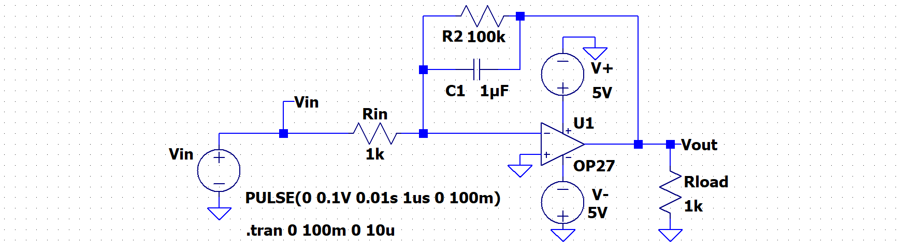

**Figure C-4.**

* Modify your schematic by changing the source from a sine to a pulse.
  + Right click on the Vin source.
  + Select PULSE
    - Set Vinitial to 0
    - Von to 0.1V (Use a small value to avoid saturating the op amp output.)
    - Tdelay to 0.01s
    - Trise to 1us
    - Tfall you can leave blank
    - Ton to 100ms
    - Others can be left blank
  + This will result with an input that is zero for the first 0.01 seconds and then 0.1V for 100ms.
* Analyze the circuit with *LTspice*.
  + Do a transient analysis for times from 0 to 100ms with a step of 10us.
  + Rather than plotting the output voltage (voltage at Vout), plot the negative of the output voltage. You should see that this circuit does seem to integrate reasonably well.
  + Copy this plot for your report.
  + How close is the output of your circuit to an integration of the input? The integration of a constant should be a ramp signal of slope equal to the constant. The output of an integrating op-amp circuit should be the inversion of the ramp signal multiplied by a constant equal to (1/(R1C1)).
  + Calculate the approximate slope of the output, this should be done at the time when the input pulse starts. Write your estimate of the slope on the output plot. Also write the theoretical slope on the plot. For what range of times does it integrate reasonably well? (This is somewhat subjective.)
* Modify the feedback capacitor
  + Decrease C1 to 0.01μF and repeat the simulation. Only run it for 11ms and start saving data after 9ms. Don’t forget to plot the negative of the output voltage. You may change the run time and start saving time is you feel it provides a clearer indication of the operation of this circuit.
  + Copy your output.
  + Mark the theoretical slope on the plot. Calculate the theoretical slope of the output. Don’t forget that the constant, 1/(R1C1), is different because C1 has changed.
  + Does the circuit integrate -- even approximately -- for any period of time? Can you think of any reason why we might prefer to use a smaller capacitor in the feedback loop, even though the circuit does not integrate as well over as long a period of time?

*Building an Op-amp Integrator and an Op-amp Differentiator*

In this part of the experiment, we will build an op-amp integrator and an op-amp differentiator on the protoboard and look at the output for a variety of inputs.

* On your proto-board, build the op-amp integrator circuit as shown in Figure C-3 using the OP27 amplifier. Note that this circuit may not work with a uA741 op amp, R2 may need to be changed to a lower value.
* Observe the behavior of the circuit at three representative frequencies.
  + Use the sine wave from the waveform generator for the voltage source, set the amplitude to 0.5V (1.0VP-P).
  + Obtain measurements of the input and output voltages at frequencies of 100Hz, 1kHz, and 5kHz. Add your experimental points for both the amplitude and phase to your *LTspice* AC analysis plot done for Figure C-3 simulation.
  + For the output channel, there is an option to subtract the average from the signal. This is done in software after the signal has been digitized with the offset. It won’t work if the inputs exceed the allowed range.   
    For the output channel, scroll down on the channel time and voltage setting to see “Software AC Coupling”. *You may find it useful to better determine the sine wave component of the output signal. The DC component is due to non-ideal behavior of the op amp and isn’t part of our analysis.*
  + Obtain a picture of each of these signals with the M2K software.
* Observe the output of the integrator for different types of inputs
  + Set the Signal Generator to a frequency that gives reasonable signal amplitude and integrates fairly well. This is somewhat subjective; we just want you to see the shapes of the outputs for different input wave shapes.
  + Set the Signal Generator to the following types of inputs:
* sine wave
* triangular wave
* square wave
  + What should the integration of each of these types of inputs be? Please don’t report that the integral of a triangle wave is a sinewave.
  + Take a picture of the output and the input with the M2K software, for each of the inputs. Remember: Plotting the input is always required, if possible, even if it isn’t explicitly stated in the experiment or project.
* Build an ideal integrator
  + The circuit we have been looking at is a Miller integrator. An ideal integrator does not have an extra resistor in the feedback path. What would happen if we changed our circuit to an ideal integrator?
  + Remove the resistor from the feedback loop.
  + Return to a sine wave input, 1kHz.
  + You should see that the circuit no longer works. **You need to have the “Software AC Coupling” turned off to see what is happening.**
  + Copy your output.
  + What is wrong with the output? The ideal integrator circuit will operate on both the AC and DC inputs. In any real circuit -- no matter how good your equipment is -- noise will create a small variable DC offset voltage at the inputs. The problem with this circuit is that there is no DC feedback to keep the DC offset at the input from being integrated. Therefore, the output voltage will continuously increase and, in addition, it will be amplified by the full intrinsic gain of the op-amp. This saturates the op-amp.
* Create a differentiator.

**Figure C-5. The probes indicate the input and output points.**

* + Remove the feedback capacitor, C2. Replace R1 with an input capacitor, C3=1μF. Replace the feedback resistor with a 1k resistor, labeled R4 in this diagram. Your circuit should now look like Figure C-5.
* Set the Signal Generator to a frequency that gives a reasonable signal amplitude and differentiates fairly well. This is somewhat subjective; we just want you to see the shapes of the outputs for different input wave shapes. You may find that your output is very noisy and thus it is hard to clearly see whether or not the circuit is acting like a differentiator. Read the handout on Integrators and Differentiators to find a suggestion for how to address the noise issue.
* Observe the output of the differentiator for different types of inputs.
  + Set the Signal Generator to the following types of inputs:
* sine wave
* triangular wave
* square wave
* What should the differentiation of each of these types of inputs be?
* Take a picture of each situation with the M2K software.

**Summary**

Op-amp circuits can be used to do both integration and differentiation. The ideal versions of both circuits are not realizable. Therefore, the real versions of these circuits do not work well at all frequencies. Also, as both types of circuits approach optimal mathematical performance, the amplitude of the output decreases. This makes designing an integrator or a differentiator a trade-off between the desired mathematical operation and signal strength.

**Part D – Using Op-Amps to Add and Subtract Signals**

**Background**

*Op-amp adders:* Figure D-1 below shows an *adder*. Its behavior is governed by the following equation: .

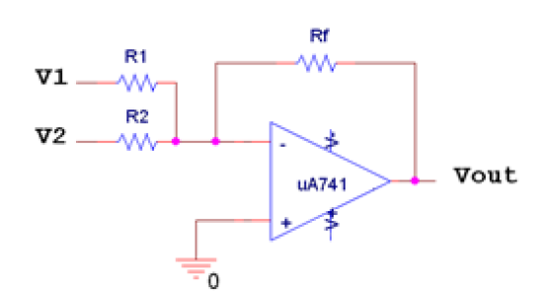

**Figure D-1.**

The gain for each input to the adder depends upon the ratio of the feedback resistance of the circuit to the value of the resistor at that input. The adder is sometimes called a weighted adder because it provides a means of multiplying each of the inputs by a separate constant before adding them all together. It can be used to add any number of inputs and multiply each input by a different constant. This makes it useful in applications like audio mixers.

*The differential amplifier:* The circuit in Figure D-2 is a *differential amplifier,* also called a *difference amplifier*. Its behavior is governed by the following equation: .

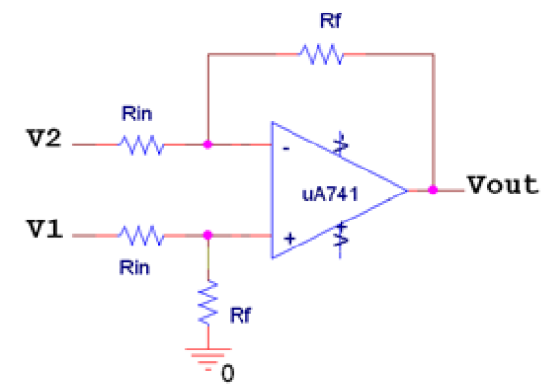

**Figure D-2.**

It amplifies the difference between the two input voltages by Rf/Rin, which is the overall gain for the circuit. Note that the ability of this amplifier to effectively take the difference between two signals depends on the fact that it uses two pairs of identical resistances. Also note that the signal that is subtracted goes into the negative input to the op-amp. Be careful with the term “differential”. In spite of its similarity to the term “differentiation”, the differential amplifier does not differentiate its input.

*Amplifying the output of a bridge circuit:* You will see in Experiment 5, that it is difficult to measure the AC voltage across the output of a bridge circuit because both of the output connections will have a finite DC voltage. The differential amplifier allows us to get by this problem, since neither input is grounded. A very large fraction of measurement circuits use some kind of a bridge configuration or are based on some kind of comparison between two voltages. Thus, the operation of the differential amplifier is very important to understand for project 2.

**Experiment**

# *LTspice* Simulation of an Adder



**Figure D-3. Note: by using the same label on the power supply and on the appropriate pin of the OP27 we connect the two without visible wires.**

* Set up the circuit shown in Figure D-3 in *LTspice*.
  + Note the polarity of the voltage sources providing ±Vcc to the op-amp.
  + Note that the power supply voltages are +15V and -15V for this simulation.
  + Figure D-3 shows a method to avoid too many wires close to the op amp. By using the same name to label the power source supply and the power pin of the op amp they are electrically connect.
  + Set signal V3 to a sine wave with 2V amplitude and 1kHz.
  + Set signal V4 to a sine wave with 1V amplitude and 10kHz.
* Run a simulation that shows 3 cycles of the 1kHz input.
  + What is the gain of the adder? Indicate if the gain is positive or negative. What should it do to the two input signals? Is the adder working correctly?
  + Include this simulation with your report.
* Adders are often used as mixers that give different emphasis to each input signal and then combine the inputs together into one signal. What would we have to set R2 to, if we wanted twice as much of the signal from V3 to pass through the adder as the signal from V4. [Note: This does not mean changing nothing because V3 already has twice the amplitude as V4. It means mixing in twice as much of the amplitude of V3 as the amplitude of V4 into the final output signal.]
  + Modify resistor R2, rerun the simulation, and verify that the output of the signal is as expected.
  + Include the output of the simulation in your report.

**Summary**

In this experiment we used an adder to add two signals. Then, we modified it so that it would combine the signals with different emphasis, as in an audio mixer.

**Checklist and Conclusions**

# The following should be included in your experimental checklist. Everything should be labeled and easy to find. Partial credit will be deducted for poor labeling or unclear presentation. ALL PLOTS SHOULD INDICATE WHICH TRACE CORRESPONDS TO THE SIGNAL AT WHICH POINT.

# Hand-Drawn Circuit Diagrams for all circuits that are to be analyzed using *LTspice* or physically built and characterized using your M2K board.

**Part A – Introduction to Op-Amp Circuits (14 points)**

Include the following plots:

1. *LTspice* transient of inverting amplifier with input amplitude of 200mV (400mV p-p) and both traces marked. (2 pt)

2. *LTspice* transient of inverting amplifier with input amplitude of 1V and both traces marked. (2 pt)

3. M2K picture of input and output voltages for the inverting amplifier circuit. (2 pt)

Answer the following questions:

1. What is the theoretical gain of your inverting amplifier? What gain did you find with *LTspice* when the input amplitude was 200mV? How close are these? (2 pt)

2. What was the actual gain you got for the inverting amplifier you built? How did this compare to the theoretical gain? How did this compare to the *LTspice* gain? (2 pt)

3. What value did you get for the saturation voltage of the OP27 op-amp in *LTspice*? What value did you get for the saturation voltage of the real op-amp in your circuit? How do they compare? (2 pt)

4. At what input voltage did the op-amp in the amplifier you built on the protoboard begin to saturate? (2 pt)

**Part B - Voltage Followers (10 points)**

Include the following plots:

1. *LTspice* transient of the voltage divider with 100Ω load and no voltage follower. (1 pt)

2. *LTspice* transient of the voltage divider with 100Ω load and a voltage follower. (1 pt)

3. *LTspice* transient of the voltage divider with 1Ω load and a voltage follower. (1 pt)

4. *LTspice* AC analysis of the input impedance for the voltage follower. (2 pt)

Answer the following questions:

1. Compare the transients of the output with and without the buffer circuit in place. What is the function of the buffer circuit? (2 pt)

2. Why is the follower unable to work properly with a small load resistor? (1 pt)

3. What is the typical value of the input impedance of the voltage follower when it is working properly at low frequencies? (1 pt)

4. Is the magnitude of the input impedance of the voltage follower high enough at high frequencies for it to work effectively? (1 pt)

**Part C – Integrators and Differentiators (38 points)**

Include the following plots:

1. *LTspice* transient plot of the integrator. (1 pt)
2. AC analysis of amplitude (with three experimental points marked) and phase (with three experimental points marked.) The frequency at which the phase gets close to ideal should also be marked. (3 pt)
3. AC analysis plot of the integrator voltage and -Vin/ωRC with the location of fc and the place where the voltage gets close to ideal indicated. (2 pt)
4. *LTspice* plots of the integrator with DC source with slope and theoretical slope (if any) indicated on plot. One should be when C2=1uF and the other for C2=0.01uF (2 plots) (2 pt)
5. M2K pictures of your circuit trace (input vs. output) at 100Hz, 1kHz and 5kHz. (3 plots) (3 pt)
6. M2K pictures of your integrator input and output with sine wave, triangular wave and square wave inputs (input vs. output) (3 plots) (3 pt)
7. M2K plot of the ideal integrator (without feedback resistor) (1 pt)
8. M2K picture of your differentiator output with sine wave, triangular wave and square wave inputs (input vs. output) (3 plots) (3 pt)

Answer the following questions:

1. Using the rules for analyzing circuits with op-amps, derive the relationship between Vout and Vin for the integrator circuit. (3 pt)
2. Why is the integrator also called a low-pass filter? Take the limits of the transfer function at high and low frequencies to demonstrate this. (3 pt)
3. What are the features of the AC analysis and transient analysis of an integrator that show it is working more-or-less as expected according to the transfer function? For about what range of frequencies does it act like an inverting amplifier? For about what range of frequencies does it act like an integrator? (3 pt)
4. Consider the phase shift and the change in amplitude of the output in relation to the input when the circuit is behaving like an integrator. Use the expected change in phase and amplitude (from the ideal equation) to demonstrate that the circuit is actually integrating. (3 pt)
5. Why would we prefer to use the 0.01uF capacitor in the feedback loop even though the circuit does not integrate quite as well over as large a range? (1 pt)
6. In the hardware implementation, you used a square-wave input to demonstrate that the integrator was working approximately correctly. If it were a perfect integrator, what would the output waveform look like? Is it close? (3 pt)
7. What happens when we try to use an ideal integrator? (1 pt)
8. When we built the differentiator, what did the output waveform look like for the square-wave input? What did the differentiator circuit output look like for a triangular wave input? If it were a perfect differentiator, what would the output waveform look like? Is it close? (3 pt)

**Part D – Using Op-Amps to Add and Subtract Signals (10 points)**

Include the following plots:

1. Transient simulation of the output of the adder with both input resistors set to 1k. (1 pt)

2. Transient simulation from *LTspice* with R2 modified. (1 pt)

Answer the following questions:

1. Demonstrate that the original adder circuit (figure D-3) works as expected. (3 pt)

2. Demonstrate that the modified adder circuit (modified figure D-3) works as expected. (3 pt).

3. Give an example of a system (electrical, mechanical, chemical or some combination) with negative feedback and an example of a system with positive feedback. (2 pt)

**Overall (8 points)**

1. Material should be in logical order, easy to follow and complete. (8pt)

**List group member *responsibilities*. (0 to -4pts)** Note that this is a list of *responsibilities* as you reported in Exp 1, 2 and 3. This isn’t the personal efforts as reported for Project 1. It is very important that you divide the responsibility for each aspect of the experiment so that it is clear who will make sure that it is completed. Responsibilities include, but are not limited to, reading the full write up before the first class; collecting all information and writing the report; building circuits and collecting data (i.e. doing the experiment); setting up and running the simulations; comparing the theory, experiment and simulation to develop the practical model of whatever system is being addressed, etc.

**Summary/Overview** (0 to -10 pts) There are two parts to this section, both of which require revisiting everything done on this experiment and addressing broad issues. Grading for this section works a bit differently in that the overall report grade will be reduced if the responses are not satisfactory.

1. 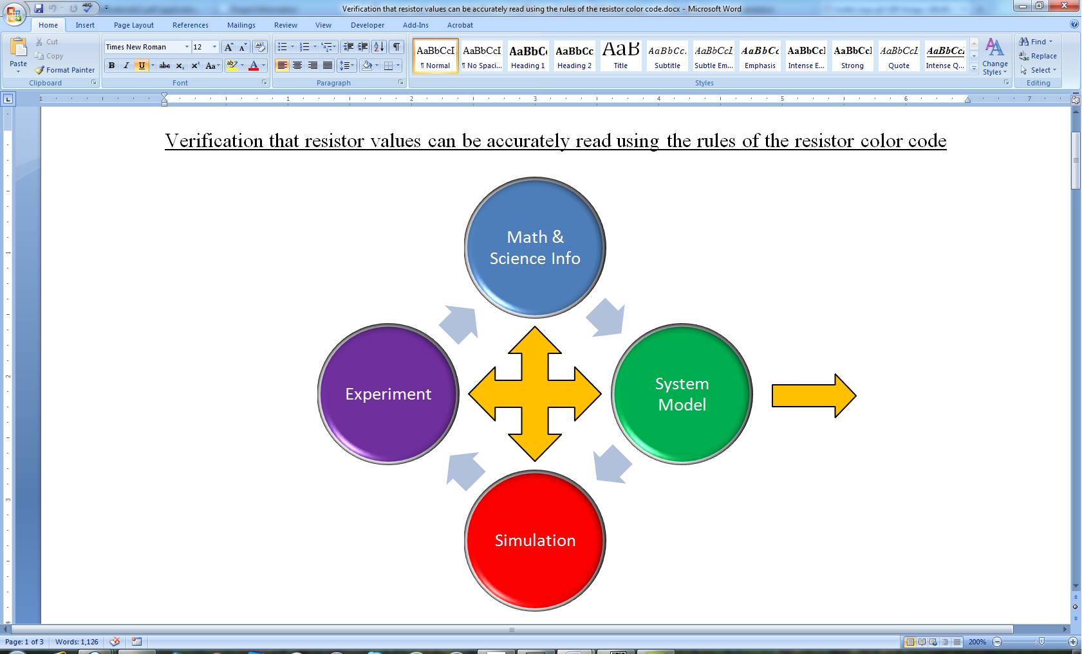Application: Identify at least one application of the content addressed in this experiment. That is, find an engineered system, device, process that is based, at least in part, on what you have learned. You must identify the fundamental system and then describe at least one practical application.
2. Engineering Design Process: Describe the fundamental math and science (ideal) picture of the system, device, and process you address in part 1 and the key information you obtained from experiment and simulation. Compare and contrast the results from each of the task areas (math and science, experiment, simulation) and then generate one or two conclusions for the practical application. That is, how does the practical system model differ from the original ideal?

Note that 2 is almost done for you in the handout

Engineering Design Process

on Integrators and Differentiators, but you should

include your version of the discussion here.

**Total: 80 points for experiment packet**

**0 to -10 points for Summary/Overview**

**20 points for attendance**

**100 points**

**Attendance (20 possible points)**

**2 classes (20 points), 1 class (10 points), 0 class (0 points)**

**Minus 5 points for each late.**

**No attendance at all = No grade for this experiment.**

***Experiment 4 (5V supplies)***

***Section: ______***

***Report Grade: ______***

***__________________________ Name***

***__________________________ Name***

***Checklist w/ Signatures for Main Concepts***

*For all plots that require a signature below, you must explain to the TA or instructor:*

* *the purpose of the data (using your hand-drawn circuit diagram),*
* *what information is contained in the plot and*
* *why you believe that the plot is correct.*

*Any member of your group can be asked for the explanation.*

**PART A: Introduction to Op-Amp Circuits**

* 1. ***LTspice***  **transient of inverting amplifier** **input Amp=200mV both traces**
  2. ***LTspice***  **transient of inverting amplifier** **input Amp=1V both traces**
  3. **M2K picture of inverting amplifier circuit ________________**

**Question 1-4**

**PART B: Voltage Followers**

1. ***LTspice* transient of voltage divider: 100Ω load and no voltage follower**
2. ***LTspice* transient of voltage divider: 100Ω load and a voltage follower**
3. ***LTspice* transient of voltage divider: 1Ω load and a voltage follower __________**
4. ***LTspice*** AC analysis **of the input impedance for the voltage follower**

**Questions 1-4**

**PART C: Integrators and Differentiators**

1. ***LTspice* transient plot of the integrator**
2. AC analysis **of amplitude with markings listed above**
3. AC analysis **plot of the integrator voltage with markings listed above**
4. ***LTspice* plots of the integrator with DC source: Slope and theoretical slope**

**One should be when C2=1uF and C2=0.01uF ______________**

1. **IO Board pictures of your circuit trace at 100Hz, 1kHz, 5kHz (3 plots)**
2. **M2K pictures of your integrator input and output with sine wave, triangular wave and square wave inputs (3 plots) _________________________**
3. **M2k plot of the ideal integrator**
4. **M2K picture of your differentiator output with sine wave, triangular wave and square wave inputs**

**Questions 1-8**

**PART D: Using Op-Amps to Add and Subtract Signals**

1. **Transient simulation of the output of the added both resistors 1k**
2. **Transient simulation from *LTspice* with R2 modified**

**Questions 1-3**

**Team interaction + Summary/Overview**